

Requirement & Design Specification

**MemoryCall**

**Version: 1.0**

– Hanoi, July 2024 –

# Record of Changes

|  |  |  |  |  |
| --- | --- | --- | --- | --- |
| **Version** | **Date** | **A* M, D** | **In charge** | **Change Description** |
| V1.0 | 03/06 | A | DatDT |  |
| V1.1 | 03/06 | A | CuongLM | Add class and sequence diagram |
| v.1.2 | 11/07 | A | DatDT | Add class and sequence diagram |
| v.1.3 | 15/07 | A | DatDT |  |
| v 1.4 | 16/07 | M | CuongLM | Change sequence diagram |
|  |  |  |  |  |
|  |  |  |  |  |
|  |  |  |  |  |
|  |  |  |  |  |
|  |  |  |  |  |
|  |  |  |  |  |
|  |  |  |  |  |

Contents

Contents

Record of Changes 2

I. Overview 8

1. User Requirements 8

1.1 Actors 8

1.2 Use Cases 9

2. Overall Functionalities 13

2.1 Screens Flow 13

2.2 Screen Descriptions 15

2.3 Screen Authorization 17

2.4 Non-UI Functions 18

3. System High Level Design 18

3.1 Database Design 18

3.2 Code Packages 20

II. Requirement Specifications 20

1. Common 20

1.1 Home page 20

2. Manage Authentication 20

2.1 Register 20

2.2 Login 21

2.3 Forgot password 21

3. Manage Course 22

3.1 View course detail 22

3.2 View all course 22

3.3 Search course 23

3.4 Filter course 23

3.5 Add course 24

3.6 Enroll/Unenroll course 25

3.7 View course enrolled 25

3.8 View course studying 26

3.9 View course completed 26

4. Manage Flashcard 27

4.1 Add flashcard 27

III. Screen Designs 28

1. Common Feature 28

1.1 Landing page 28

1.2 Home page 29

2. Manage Authentication 30

2.1 Register 30

2.2 Login 30

2.3 Forgot password 31

2.4 Change password 32

3. Manage course 34

3.1 Course detail 34

3.2 View course by search and filter category 35

3.3 View course by staff name 36

3.4 View course enrolled 37

3.5 View course studying 38

3.6 View course completed 38

3.7 Add course 39

4. Manage flashcard 40

4.1 Add flashcard 40

4.2 View and Search and Filter flashcard 41

4.3 Update flashcard 42

5. Manage category 43

5.1 View and search category 43

5.2 Update category 43

5.3 Create category 44

6. Manage discussions 44

6.1 View all discussion forum 44

6.2 Search discussion 45

6.3 Filter discussion 46

6.4 Comment 46

7. Manage account 46

7.1 View profile 46

7.2 Update profile 47

8. Manage top ranking 48

8.1 View top ranking 48

9. Manage admin 50

9.1 View all staff 50

9.2 Search staff 50

9.3 Add staff 51

9.4 Active/Deactive staff 52

10. Manage course 52

10.1 View course by staff 52

10.2 Edit course 53

11. Manage student 53

11.1 View course by staff 53

11.2 View student by class 54

12. Manage practice 55

12.1 Multiple choice 55

12.2 Result 55

12.3 Fill in blank 56

12.4 Matching 57

13. Manage Statistic 57

13.1 Staff Dashboard 57

13.2 Admin Dashboard 57

IV. Code Designs 58

1. Register 58

1.1 Class Diagram 58

1.2 Sequence Diagram 59

1.3 Database Queries 59

2. Login 59

2.1 Class Diagram 59

2.2 Sequence Diagram 60

2.3 Database Queries 60

3. Forgot Password 61

3.1 Class Diagram 61

3.2 Sequence Diagram 62

3.3 Database Queries 62

4. Home Page 62

4.1 Class Diagram 62

4.2 Sequence Diagram(s) 62

4.3 Database Queries 62

4.3.1 getTop6NewestCourse() 62

4.3.1 getTop6NewestCourse() 63

5. View course by search and filter category 63

5.1 Class Diagram 63

5.2 Sequence Diagram(s) 64

5.3 Database Queries 64

5.3.1 getAllCourses2 64

5.3.2 getCourseByName2(String course_name) 64

5.3.3 getCouseByCategoryID(String category_id) 64

5.3.3 getCouseByCategoryIDandName(String category_id, String course_name) 64

6. View Top Ranking 65

6.1 Class Diagram 65

6.2 Sequence Diagram(s) 65

6.3 Database Queries 65

6.3.1 getTopRanking() 65

6.3.2 getAllTypeOfPractices() 66

6.3.3 getResultByTOP_ID(int typeOfPractice_id) 66

7. View all courses enrolled 66

7.1 Class Diagram 66

7.2 Sequence Diagram(s) 66

7.3 Database Queries 66

8. Search and Filter course enrolled 66

8.1 Class Diagram 66

8.2 Sequence Diagram(s) 66

8.3 Database Queries 66

9. Course detail 67

9.1 Class Diagram 67

9.2 Sequence Diagram(s) 67

9.3 Database Queries 67

10. Practice Multiple Choice 68

10.1 Class Diagram 68

10.2 Sequence Diagram(s) 68

10.3 Database Queries 68

11. ManageCourse 69

11.1 Class Diagram 69

11.2 Sequence Diagram(s) 69

11.3 Database Queries 69

11.3.1 getCouseByUserId(int user_id) 69

# I. Overview

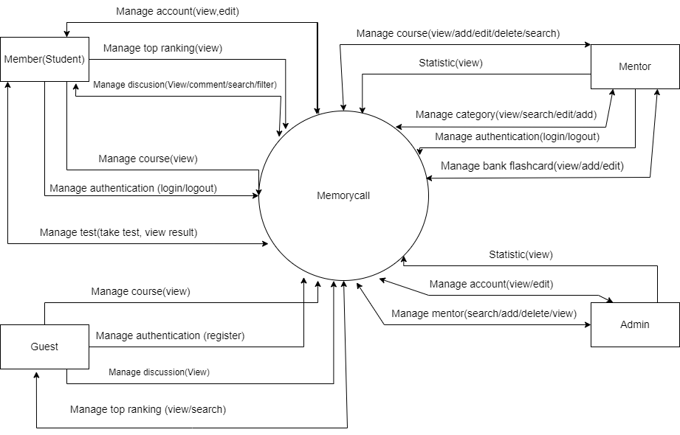

## 1. User Requirements

### 1.1 Actors

|  |  |  |
| --- | --- | --- |
| **#** | **Actor** | **Description** |
| 1 | Guest | Non-registered visitor |
| 2 | Student | Registered learner in learning website. |
| 3 | Staff | A person responsible for managing course and class |
| 4 | Admin | A person who manages and oversees administrative tasks to keep things running smoothly in an organization or system. |

### 1.2 Use Cases

#### a. Diagram(s)

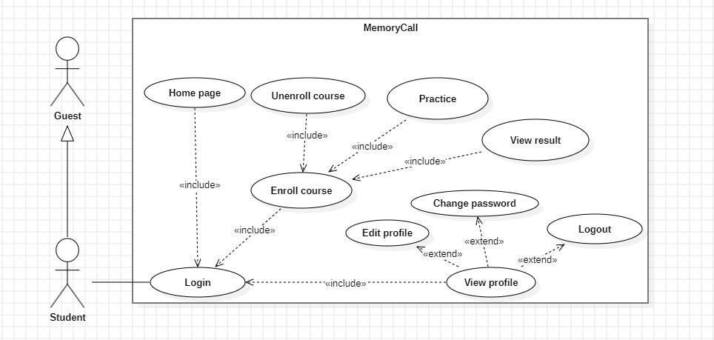

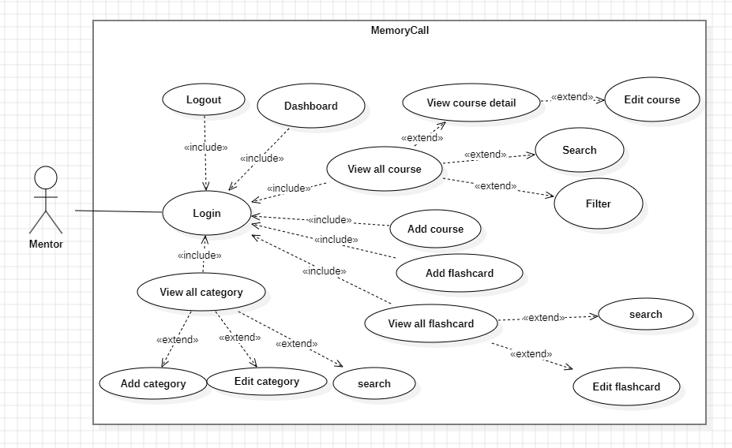

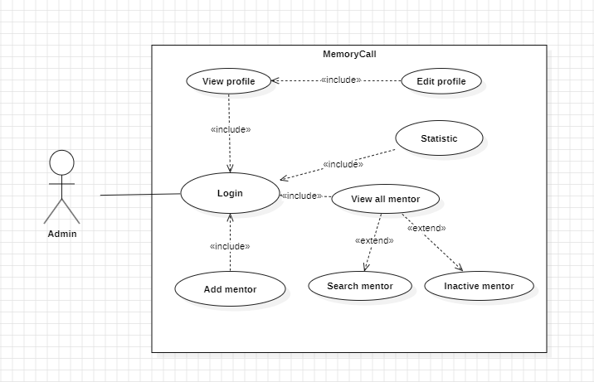

#### b. Descriptions

|  |  |  |  |
| --- | --- | --- | --- |
| **ID** | **Feature** | **Use Case** | **Use Case Description** |
| 1 | Common | View landing page | Users can access the inistial page of the platform, showcasing key features, announcements, and an overview of the platform's offerings. |
| 2 | Common | View home page | After logging in, users are taken to the home page where they can see personalized information, recommended courses, recent activity, and quick links to different sections. |
| 3 | Manage  Authentication | Register | New users can create an account by providing necessary details like name, email, and password. |
| 4 | Login | Existing users can sign into their accounts using their email and password |
| 5 | Logout | Users can securely log out of their accounts to end their session |
| 6 | Forgot password | Users who have forgotten their password can request a password reset link to be sent to their registered email. |
| 7 | Change password | Logged-in users can change their current password from their account settings for security purposes. |
| 8 | Manage Course | View all course | Users can browse a list of all available courses offered on the platform. |
| 9 | Search course | Users can search for specific courses by entering keywords or course titles. |
| 10 | Filter course | Users can filter courses based on various criteria such as category, level, price, and rating. |
| 11 | Enroll/Unenroll course | Users can enroll in courses they are interested in and unenroll from courses they no longer wish to participate in. |
| 12 | Add course | Authorized users (e.g., staffs or administrators) can create new courses by providing course details and content. |
| 13 | Edit course | Authorized users can edit the details of existing courses, such as updating content or changing course information. |
| 14 | View course detail | Users can view detailed information about a specific course, including syllabus, instructor information, and reviews. |
| 15 | View course enrolled | Users can see a list of courses they are currently enrolled in. |
| 16 | View course studying | Users can track the courses they are actively studying. |
| 17 | View course completed | Users can view a list of courses they have completed, often with certificates or completion badges. |
| 18 | Manage bank flashcard | View all flashcard | Users can browse all available flashcards in the flashcard bank. |
| 19 | Search flashcard | Users can search for specific flashcards by entering keywords or topics. |
| 20 | Filter flashcard | Users can filter flashcards based on categories, difficulty, and other criteria. |
| 21 | Edit flashcard | Authorized users can edit the content of existing flashcards. |
| 22 |  | Add flashcard | Authorized users can create new flashcards by providing questions and answers. |
| 23 | Manage Discussion | View all discuss forum | Users can browse all discussion forums available on the platform. |
| 24 | Search discussion | Users can search for specific discussions by entering keywords or topics. |
| 25 | Filter discussion | Users can filter discussions based on topics, recent activity, and other criteria. |
| 26 | Comment | Users can post comments and replies in discussion forums to participate in conversations. |
| 27 | Statistic | View number of user registered | Administrators can view the total number of users registered on the platform. |
| 28 | View all number of course created | Administrators can view the total number of courses created on the platform. |
| 29 |  | View number of student enroll course | Administrators can view statistics on how many students are enrolled in each course. |
| 30 | Manage staff | View all staff | Admin can browse a list of all staffs available on the platform. |
| 31 | Search staff | Admin can search for specific staffs by entering keywords or names. |
| 32 | Add staff | Administrators can add new staffs by providing their details and qualifications. |
| 33 | Active/Inactive staff | Administrators can activate or deactivate staffs, controlling their ability to interact with students on the platform. |
| 34 | View staff detail | Admin can view detailed information about a specific staff, including their biography, courses they teach, and reviews. |
| 35 | Manage category | View all category | staff can browse all course categories available on the platform. |
| 36 | Search category | staff can search for specific categories by entering keywords. |
| 37 | Add category | staff can add new course categories to organize the courses better. |
| 38 | Edit category | staff can edit existing course categories to update or correct information. |
| 39 | Manage top ranking | View top ranking page | Users can view a page displaying top-ranking courses, students, or staffs based on various criteria. |
| 40 | Search top ranking | Users can search within the top-ranking page to find specific information or individuals. |
| 41 | Filter top ranking | Users can filter the rankings based on categories, time periods, and other criteria. |
| 42 | Manage test | Practice multiple-choice | Users can practice multiple-choice questions for their courses. |
| 43 | Practice matching | Users can practice matching exercises where they pair related items. |
| 44 | Practice fill in blank | Users can practice fill-in-the-blank exercises to test their knowledge. |
| 45 | View result | Users can view the results of their practice tests, including scores and feedback. |
| 46 | Manage account | View profile | Users can view their profile information, including personal details, course progress, and achievements. |
| 47 | Update profile | Users can update their profile information, such as their name, email, and preferences. |
| 47 |  | Update profile | Users can update their profile information, such as their name, email, and preferences. |

## 2. Overall Functionalities

### 2.1 Screens Flow

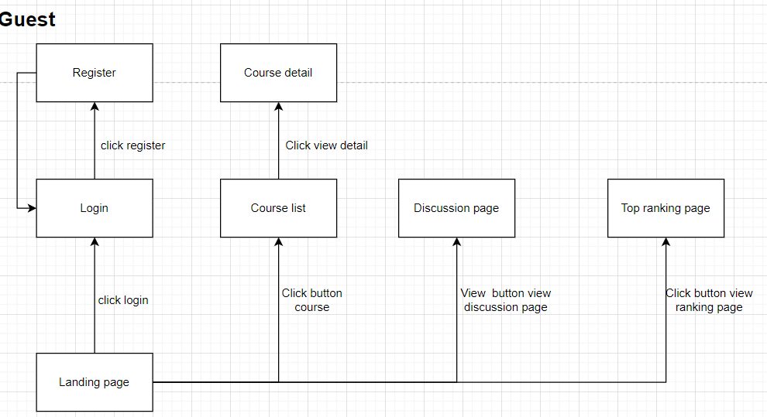

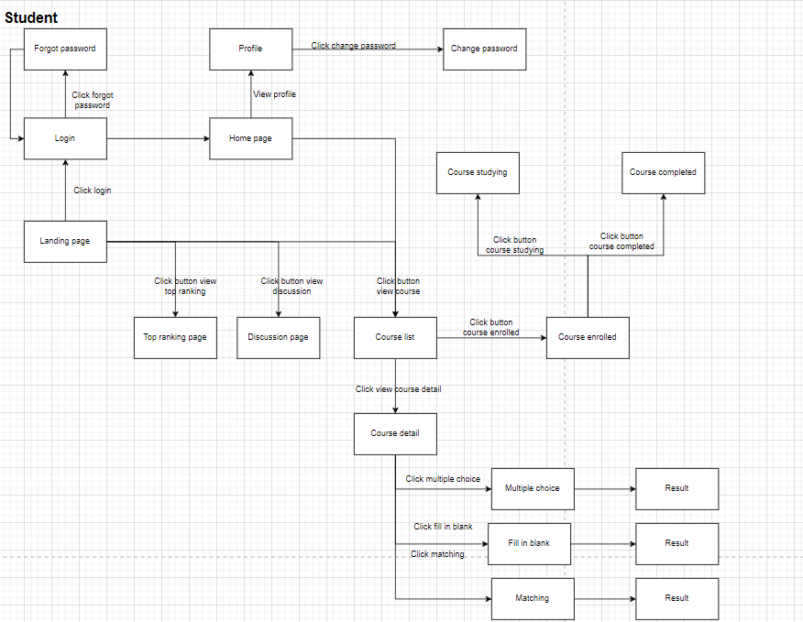

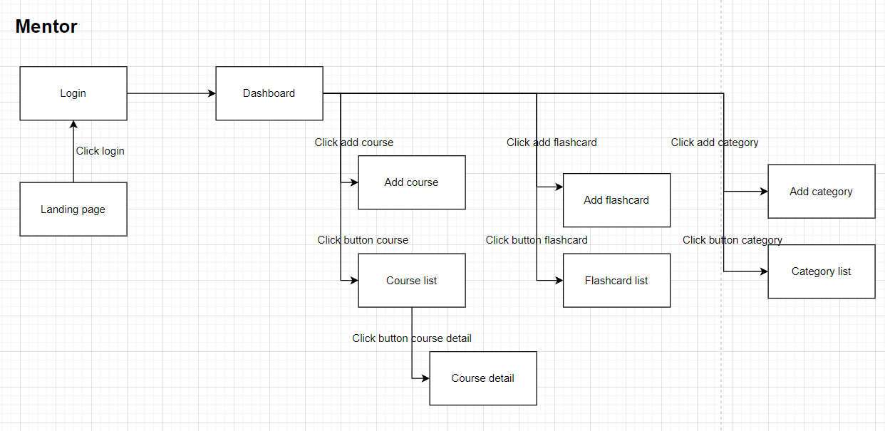

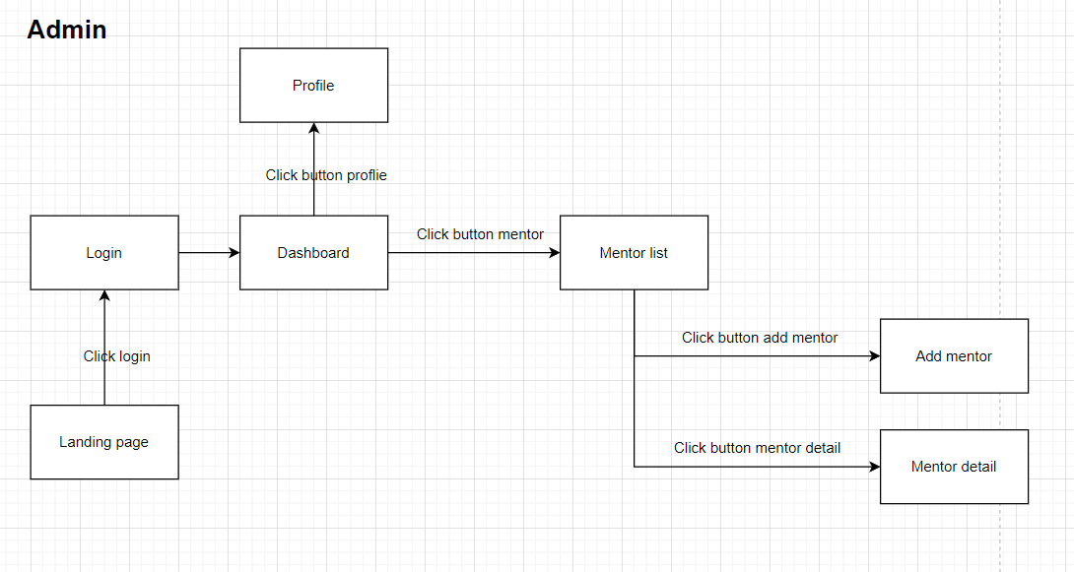

### 2.2 Screen Descriptions

|  |  |  |  |
| --- | --- | --- | --- |
| **#** | **Feature** | **Screen** | **Description** |
| 1 | Common | View landing page | Users can access the initial page of the platform, showcasing key features, announcements, and an overview of the platform's offerings. |
| 2 |  | View home page | After logging in, users are taken to the home page where they can see personalized information, recommended courses, recent activity, and quick links to different sections. |
| 3 | Manage  Authentication | Register | New users can create an account by providing necessary details like name, email, and password. |
| 4 | Login | Existing users can sign into their accounts using their email and password |
| 5 | Logout | Users can securely log out of their accounts to end their session |
| 6 | Forgot password | Users who have forgotten their password can request a password reset link to be sent to their registered email. |
| 7 | Change password | Logged-in users can change their current password from their account settings for security purposes. |
| 8 | Manage Course | View all course | Users can browse a list of all available courses offered on the platform. |
| 9 | Enroll/Unenroll course | Users can enroll in courses they are interested in and unenroll from courses they no longer wish to participate in. |
| 10 | Add course | Authorized users (e.g., staffs or administrators) can create new courses by providing course details and content. |
| 11 | Edit course | Authorized users can edit the details of existing courses, such as updating content or changing course information. |
| 12 | View course detail | Users can view detailed information about a specific course, including syllabus, instructor information, and reviews. |
| 13 | View course enrolled | Users can see a list of courses they are currently enrolled in. |
| 14 | View course studying | Users can track the courses they are actively studying. |
| 15 | View course completed | Users can view a list of courses they have completed, often with certificates or completion badges. |
| 16 | Manage bank flashcard | View all flashcard | Users can browse all available flashcards in the flashcard bank. |
| 17 | Edit flashcard | Authorized users can edit the content of existing flashcards. |
| 18 | Add flashcard | Authorized users can create new flashcards by providing questions and answers. |
| 19 | Manage Discussion | View all discuss forum | Users can browse all discussion forums available on the platform. |
| 20 | Comment | Users can post comments and replies in discussion forums to participate in conversations. |
| 21 | Statistic | View number of user registered | Administrators can view the total number of users registered on the platform. |
| 22 | View all number of course created | Administrators can view the total number of courses created on the platform. |
| 23 | View number of student enroll course | Administrators can view statistics on how many students are enrolled in each course. |
| 24 | Manage Staff | View all staff | Admin can browse a list of all staffs available on the platform. |
| 25 | Add staff | Administrators can add new staffs by providing their details and qualifications. |
| 26 | Active/Inactive staff | Administrators can activate or deactivate staffs, controlling their ability to interact with students on the platform. |
| 27 | View staff detail | Admin can view detailed information about a specific staff, including their biography, courses they teach, and reviews. |
| 28 | Manage category | View all category | staff can browse all course categories available on the platform. |
| 29 | Add category | staff can add new course categories to organize the courses better. |
| 30 | Edit category | staff can edit existing course categories to update or correct information. |
| 31 | Manage top ranking | View top ranking page | Users can view a page displaying top-ranking courses, students, or staffs based on various criteria. |
| 32 | Manage test | Practice multiple-choice | Users can practice multiple-choice questions for their courses. |
| 33 | Practice matching | Users can practice matching exercises where they pair related items. |
| 34 | Practice fill in blank | Users can practice fill-in-the-blank exercises to test their knowledge. |
| 35 | View result | Users can view the results of their practice tests, including scores and feedback. |
| 36 | Manage account | View profile | Users can view their profile information, including personal details, course progress, and achievements. |
| 37 | Update profile | Users can update their profile information, such as their name, email, and preferences. |

### 2.3 Screen Authorization

|  |  |  |  |  |
| --- | --- | --- | --- | --- |
| **Screen** | **Guest** | **Student** | **Staff** | **Admin** |
| View landing page | x | X | x | x |
| View home page |  | X |  |  |
| Register | x | X |  |  |
| Login | X | X |  |  |
| Logout |  | x | x | X |
| Forgot password |  | x |  | X |
| Change password |  | x |  | X |
| View all course | X | x | X |  |
| Enroll/Unenroll course |  | X |  |  |
| Add course |  |  | X |  |
| Edit course |  |  | X |  |
| View course detail | x | x | X |  |
| View course enrolled |  | X |  |  |
| View course studying |  | X |  |  |
| View course completed |  | X |  |  |
| View all flashcard |  |  | X |  |
| Edit flashcard |  |  | X |  |
| Add flashcard |  |  | X |  |
| View all discuss forum | X | x |  |  |
| Comment |  | X |  |  |
| View number of user registered |  |  |  | X |
| View all number of course created |  |  |  | X |
| View number of student enroll course |  |  | X |  |
| View all staff |  |  |  | X |
| Add staff |  |  |  | X |
| Active/Inactive staff |  |  |  | X |
| View staff detail |  |  |  | X |
| View all category |  |  | X |  |
| Add category |  |  | X |  |
| Edit category |  |  | X |  |
| View top ranking page | X | x |  |  |
| Practice multiple-choice |  | X |  |  |
| Practice matching |  | X |  |  |
| Practice fill in blank |  | X |  |  |
| View result |  | X |  |  |
| View profile |  | x |  | X |
| Update profile |  | x |  | X |

### 2.4 Non-UI Functions

|  |  |  |  |
| --- | --- | --- | --- |
| **#** | **Feature** | **System Function** | **Description** |
| 1 | Common | Forgot password | Third-party send email to registered email to reset password. |
| 2 | Common | Authorization | System check permission of user when they use an authorized function |
| 3 | Common | Hash password | Password must be encrypted before adding to database to secure information |

## 3. System High Level Design

### 3.1 Database Design

#### a. Database Schema

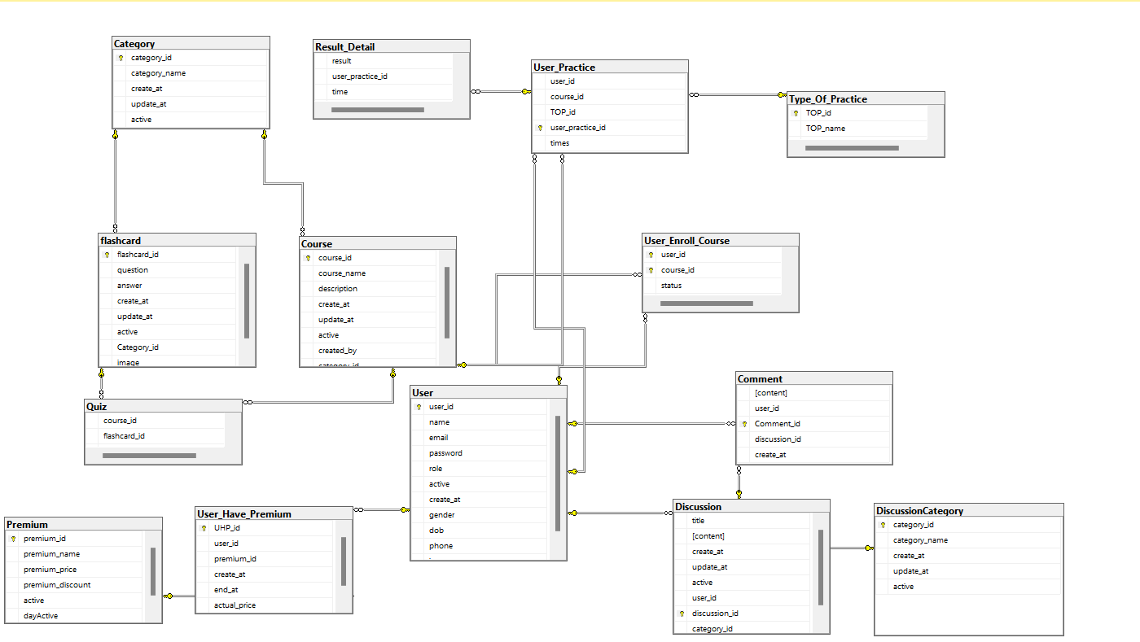

#### b. Table Descriptions

|  |  |  |
| --- | --- | --- |
| **No** | **Table** | **Description** |
| *01* | *User* | *To store user’s account information*  *- Primary keys: user_id*  *- Foreign keys: None* |
| *02* | *Course* | *To store course information*  *- Primary keys: course_id*  *- Foreign keys: category_id* |
| *03* | *User Enroll Course* | *To store who enroll for which course*  *- Primary keys: user_id, course_id*  *- Foreign keys: user_id, course_id* |
| *04* | *Quiz* | *To store which course have which flashcards*  *- Primary keys: quiz_id*  *- Foreign keys: flashcard_id, course_id* |
| *05* | *Flashcard* | *To store flashcard information*  *- Primary keys: flashcard_id*  *- Foreign keys: category_id* |
| *06* | *Category* | *To store category information*  *- Primary keys: category_id*  *- Foreign keys: None* |
| *07* | *Comment* | *To store comment*  *- Primary keys: comment_id*  *- Foreign keys: user_id* |
| *08* | *Reply* | *To store who reply the comment*  *- Primary keys: reply_id*  *- Foreign keys: reply_for* |
| *09* | *User practice* | *Store information about who is taking which course and doing which practice exercises*  *- Primary keys: user_practice_id*  *- Foreign keys: user_id, course_id, TOP_id* |
| *10* | *Result detail* | *Store result of practice*  *- Primary keys: RD_id*  *- Foreign keys: user_practice_id* |
| *11* | *Type of Practice* | *To store name of the practice*  *- Primary keys: TOP_id*  *- Foreign keys: None* |

### 3.2 Code Packages

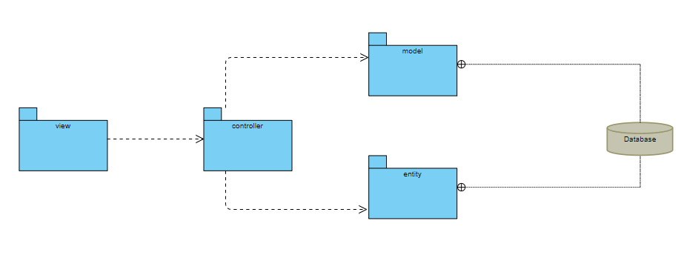

# II. Requirement Specifications

## 1. Common

### 1.1 Home page

## 2. Manage Authentication

### 2.1 Register

#### a. UC Specification

|  |  |  |  |
| --- | --- | --- | --- |
| UC Name: | **Register System** | | |
| Primary Actor: | Student | Secondary Actors: | None |
| Create by: | CuongLM | | |
| Trigger: | When users click Register now in Login page or header | | |
| Description: | *Guest can create a new Student account with user and password* | | |
| Preconditions: | 1. Guest create new account in a system 2. System check value and create new record in database 3. Redirect to login page | | |
| Postconditions: | Create new record in database | | |
| Normal Flow | 1. Guest click Register button in header 2. Fill required field(user,password) and others field 3. System check validate 4. System send email for verification 5. If success ,system create new account in database 6. Return to login page | | |
| Alternative Flows: | N/A | | |
| Exceptions: | N/A | | |
| Business Rules: | None | | |

#### b. Business Rules

None

### 2.2 Login

#### a. UC Specification

|  |  |  |  |
| --- | --- | --- | --- |
| UC Name: | **Login System** | | |
| Primary Actor: | Admin,Staff,Student | Secondary Actors: | None |
| Create by: | CuongLM | | |
| Trigger: | When users click the Login button in header | | |
| Description: | *Users login to the system by email and password* | | |
| Preconditions: | 1. User login to system 2. The system authenticates user is Admin,Staff or Student 3. Redirect to the homepage | | |
| Postconditions: | Search username and password in database | | |
| Normal Flow | **Login System**   1. User click login button in header 2. Fill user and password 3. Click the login button under password text 4. System check validate of username and password 5. System check username and password 6. System send error if user not existed,wrong or password wrong 7. System check user’s role 8. If success,redirect to the homepage | | |
| Alternative Flows: | N/A | | |
| Exceptions: | N/A | | |
| Business Rules: | None | | |

#### b. Business Rules

None

### 2.3 Forgot password

#### a. UC Specification

|  |  |  |  |
| --- | --- | --- | --- |
| UC Name: | **Forgot Password** | | |
| Primary Actor: | Student,Staff | Secondary actor: | None |
| Create by: | CuongLM | | |
| Trigger: | When users click Forgot Password ? in Login page | | |
| Description: | *The user to input his/her email to receive the reset password link. This link is sent to the user's email for his/her password resetting.Then click the link and fill the new password* | | |
| Preconditions: | 1. Guest find password 2. System change password 3. Redirect to login page | | |
| Postconditions: | Change password record in database | | |
| Normal Flow | 1. Guest click Forgot password button in Login page 2. Fill the email user want to change password 3. System send email for verification 4. User click the link in email 5. Fill the new password 6. Return to login page | | |
| Alternative Flows: | N/A | | |
| Exceptions: | N/A | | |
| Business Rules: | None | | |

#### b. Business Rules

None

## 3. Manage Course

### 3.1 View course detail

#### a. UC Specifications

**Functional Description Template**

|  |  |  |  |
| --- | --- | --- | --- |
| UC Name: | **View course detail** | | |
| Create by: | DucTD | | |
| Primary Actor: | Student | Secondary Actors: | Guest |
| Trigger: | When the user clicks on the course details | | |
| Description: | List all cards in the course, allowing users to study in the form of flashcard without logging in advance | | |
| Preconditions: | Users click to view course details | | |
| Postconditions: | The website will display the course name, course creator name, study cards, class participation and practice buttons. | | |
| Normal Flow: | **View course detail**   1. System show list of flashcard in course | | |
| Alternative Flows: | N/A | | |
| Exceptions: | N/A | | |
| Business Rules: | None | | |

#### b. Business Rules

None

### 3.2 View all course

#### a. UC Specifications

**Functional Description Template**

| UC Name: | **View course detail** | | |
| --- | --- | --- | --- |
| Create by: | DatTD | | |
| Primary Actor: | Student | Secondary Actors: | Guest |
| Trigger: | When the user clicks on the course | | |
| Description: | List all courses, allowing users and guests to see all courses of class | | |
| Preconditions: | Users or Guest see all courses | | |
| Postconditions: | The website will display all the course names,description of courses | | |
| Normal Flow: | 1. User or Guest click in Course 2. System show list of courses and descriptions | | |
| Alternative Flows: | N/A | | |
| Exceptions: | N/A | | |
| Business Rules: | None | | |

#### b. Business Rules

None

### 3.3 Search course

#### a. UC Specifications

**Functional Description Template**

| UC Name: | **Search course** | | |
| --- | --- | --- | --- |
| Create by: | DatTD | | |
| Primary Actor: | Student | Secondary Actors: | Guest |
| Trigger: | When the user clicks on search button | | |
| Description: | Find the course user or guest want to find and display it on screen | | |
| Preconditions: | Users our Guests find course | | |
| Postconditions: | The website will display the course name,description of course | | |
| Normal Flow: | 1. User or Guest insert course name 2. User or Guest click in Search button 3. System show name of the course and description need to find | | |
| Alternative Flows: | N/A | | |
| Exceptions: | N/A | | |
| Business Rules: | None | | |

#### b. Business Rules

None

### 3.4 Filter course

#### **a. UC Specifications**

**Functional Description Template**

| UC Name: | **Filter course** | | |
| --- | --- | --- | --- |
| Create by: | DatTD | | |
| Primary Actor: | Student | Secondary Actors: | Guest |
| Trigger: | When the user clicks on filter and submit button | | |
| Description: | Find the course user or guest want to find and display it on screen | | |
| Preconditions: | Users our Guests find course | | |
| Postconditions: | The website will display the course name,description of course | | |
| Normal Flow: | 1. User or Guest click in Filter category 2. User or Guest click in Submit button 3. System show name of the course and description need to find | | |
| Alternative Flows: | N/A | | |
| Exceptions: | N/A | | |
| Business Rules: | None | | |

#### **b. Business Rules**

None

### 3.5 Add course

#### a. UC Specifications

|  |  |  |  |
| --- | --- | --- | --- |
| UC Name: | **Add course** | | |
| Create by: | DucTD | | |
| Primary Actor: | Staff | Secondary Actors: | None |
| Description: | Staff create course with category and flashcard | | |
| Trigger: | The user clicks the add course button | | |
| Preconditions: | 1. User login to system 2. The system authenticates user is staff | | |
| Postconditions: | 1. Insert flashcard data and course data to quiz table in database | | |
| Normal Flow: | **Add course**   1. User choose category 2. User enter name of course 3. User choose flashcard to course 4. System check duplicate name of course 5. System display error if duplicate name of course 6. Insert to database if have no error | | |
| Alternative Flows: | **Add random flashcard to course**   1. User choose category 2. User enter name of course 3. User enter number of flashcard will be random 4. System get random flashcard by category 5. System check duplicate name of course 6. System display error if duplicate name of course 7. Insert to database if have no error | | |

#### b. Business Rules

None

### 3.6 Enroll/Unenroll course

#### a. UC Specifications

|  |  |  |  |
| --- | --- | --- | --- |
| UC Name: | **Enroll/Unenroll course** | | |
| Create by: | DucTD | | |
| Primary Actor: | Student | Secondary Actors: | None |
| Description: | Registered user can enroll course to practice quizzes or unenroll course | | |
| Trigger: | When user click enroll/unenroll button | | |
| Preconditions: | 1. User login to system 2. The system authenticates user is student | | |
| Postconditions: | Enroll/Unenroll student to class successfully | | |
| Normal Flow: | 1. System check user login 2. Give error if user do not login to system 3. Insert user enroll course to database | | |
| Alternative Flows: | **N/A** | | |
| Exceptions: | N/A | | |
| Business Rules: | None | | |

#### b. Business Rules

None

### 3.7 View course enrolled

#### a. UC Specifications

**Functional Description Template**

| UC Name: | **View course enrolled** | | |
| --- | --- | --- | --- |
| Create by: | TruongND | | |
| Primary Actor: | Student | Secondary Actors: | none |
| Trigger: | When the user clicks on the course enrolled | | |
| Description: | List all course enrolled, users can view course | | |
| Preconditions: | Users click to view course enrolled | | |
| Postconditions: | The website will display the course name, description, button view course | | |
| Normal Flow: | 1. User after login click in CourseEnrolled 2. System show list of courses enrolled and descriptions | | |
| Alternative Flows: | N/A | | |
| Exceptions: | N/A | | |
| Business Rules: | None | | |

#### b. Business Rules

None

### 3.8 View course studying

#### a. UC Specifications

**Functional Description Template**

| UC Name: | **View course studying** | | |
| --- | --- | --- | --- |
| Create by: | TruongND | | |
| Primary Actor: | Student | Secondary Actors: | none |
| Trigger: | When the user clicks on the course studying | | |
| Description: | List all course studying, users can view course | | |
| Preconditions: | Users click to view course studying | | |
| Postconditions: | The website will display the course name, description, button view course | | |
| Normal Flow: | 1. User after login click in CourseStudying   2. System show list of courses studying descriptions | | |
| Alternative Flows: | N/A | | |
| Exceptions: | N/A | | |
| Business Rules: | None | | |

#### b. Business Rules

None

### 3.9 View course completed

#### a. UC Specifications

**Functional Description Template**

| UC Name: | **View course completed** | | |
| --- | --- | --- | --- |
| Create by: | TruongND | | |
| Primary Actor: | Student | Secondary Actors: | none |
| Trigger: | When the user clicks on the course completed | | |
| Description: | List all course completed, users can view course | | |
| Preconditions: | Users click to view course completed | | |
| Postconditions: | The website will display the course name, description, button view course | | |
| Normal Flow: | 1. User after login click in CourseCompleted 2. System show list of courses completedand descriptions | | |
| Alternative Flows: | N/A | | |
| Exceptions: | N/A | | |
| Business Rules: | None | | |

#### b. Business Rules

None

## 4. Manage Flashcard

### 4.1 Add flashcard

#### a. UC Specification

|  |  |  |  |
| --- | --- | --- | --- |
| UC Name: | **Add flashcard** | | |
| Create by: | DucTD | | |
| Primary Actor: | Staff | Secondary Actors: | None |
| Description: | Staff create additional flashcards. Flashcard include terms and definitions | | |
| Trigger: | The user clicks the add flashcard button | | |
| Preconditions: | 1. User login to system 2. The system authenticates user is staff | | |
| Postconditions: | New flashcard insert in to database | | |
| Normal Flow: | **Add flashcard**   1. User choose category 2. User enter terms and definitions 3. System check duplicate question in database 4. System check duplicate question in form user entered 5. System send error if have duplicate 6. System insert into database | | |
| Alternative Flows: | **AF1. Add flashcard by Excel**   1. User choose category 2. User import file Excel 3. System display file Excel 4. System check duplicate question in database 5. System check duplicate question in form user entered 6. System send error if have duplicate 7. System insert into database | | |
| Exceptions: | N/A | | |
| Business Rules: | None | | |

#### b. Business Rules

None

# III. Screen Designs

## 1. Common Feature

### 1.1 Landing page

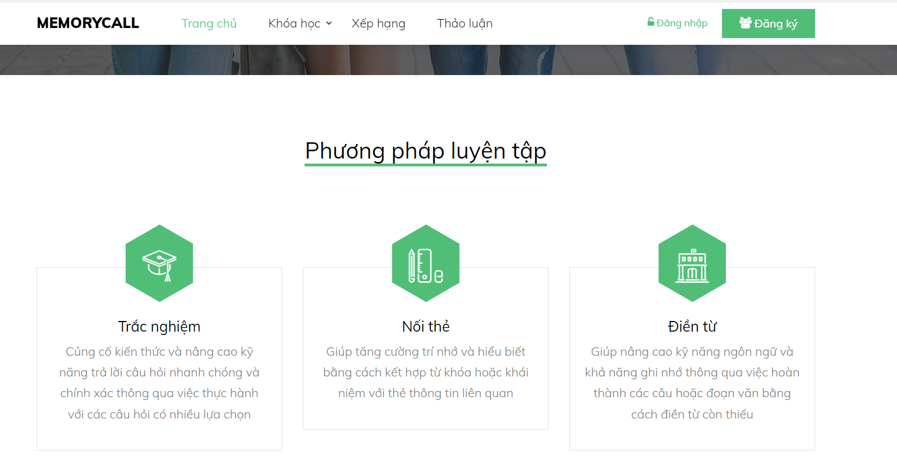

| **Field Name** | **Field Type** | **Description** |
| --- | --- | --- |
| Memorycall | HyperLink | Redirect to landing page |
| Trang chủ | HyperLink | Redirect to homepage |
| Khóa học | HyperLink | Redirect to course |
| Xếp hạng | HyperLink | Redirect to list of student on top |
| Thảo luận | Hyperlink | Redirect to discuss page |
| Đăng nhập | Button | Redirect to login page |
| Đăng kí | Button | Redirect to register page |

### 1.2 Home page

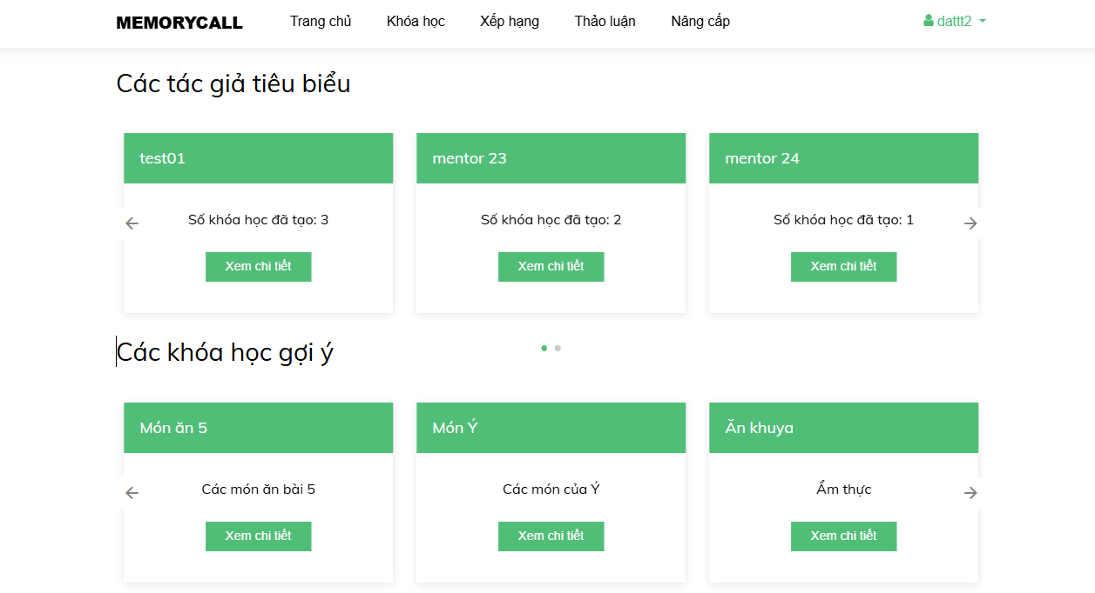

| **Field Name** | **Field Type** | **Description** |
| --- | --- | --- |
| Memorycall | HyperLink | Redirect to landing page |
| Trang chủ | HyperLink | Redirect to homepage |
| Khóa học | HyperLink | Redirect to course |
| Xếp hạng | HyperLink | Redirect to list of student on top |
| Thảo luận | Hyperlink | Redirect to discuss page |
| Nâng cấp | Hyperlink | Redirect to upgrade account page |
| Đăng kí | Hyperlink | Redirect to register page |
| dattt2 | Hyperlink | Dropdown user menu |
| Các tác giả tiêu biểu | text | Description |
| Test01 | text | Name of staff who create course |
| Số khóa học đã tạo : 2 | text | Count of courses staff have created |
| Xem chi tiết | HyperLink | Redirect to staff details screen |
| Các khóa học gợi ý | text | Description |
| Món ăn 5 | text | Name of course |
| Các món ăn bài 5 | text | Description of course |
| Xem chi tiết | HyperLink | Redirect to course details screen |

## 2. Manage Authentication

### 2.1 Register

This screen allows show input email for account you want to find account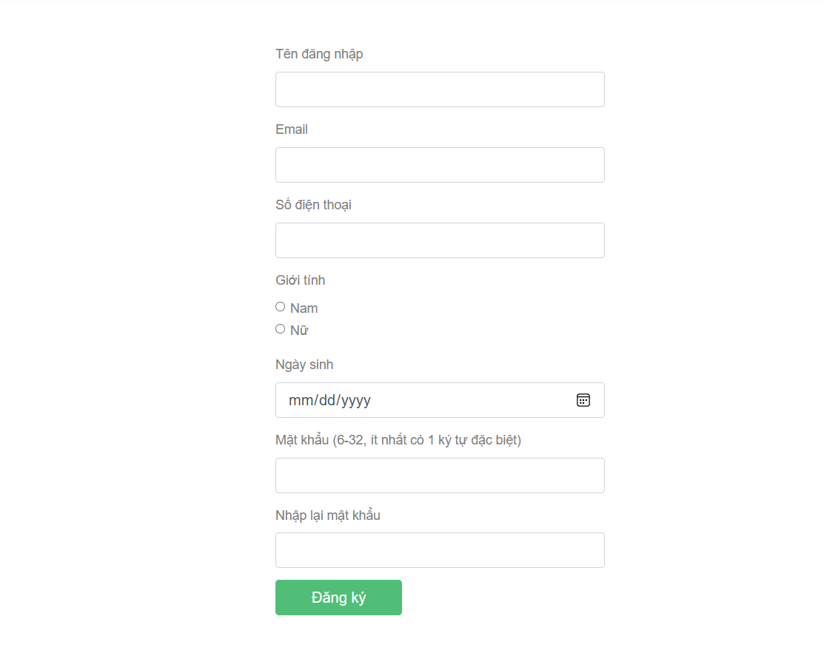

|  |  |  |
| --- | --- | --- |
| **Field Name** | **Field Type** | **Description** |
| username | text | Input username |
| email | email | Input email to register |
| phone | text | Input phone number |
| gender | checkbox | Input gender by ticking the box |
| DOB | text | Input date of birth |
| password | password | input password |
| re-password | password | input password again to confirm |
| Đăng ký | button | click to register the user |

### 2.2 Login

This screen allows to fill username and password to login an account

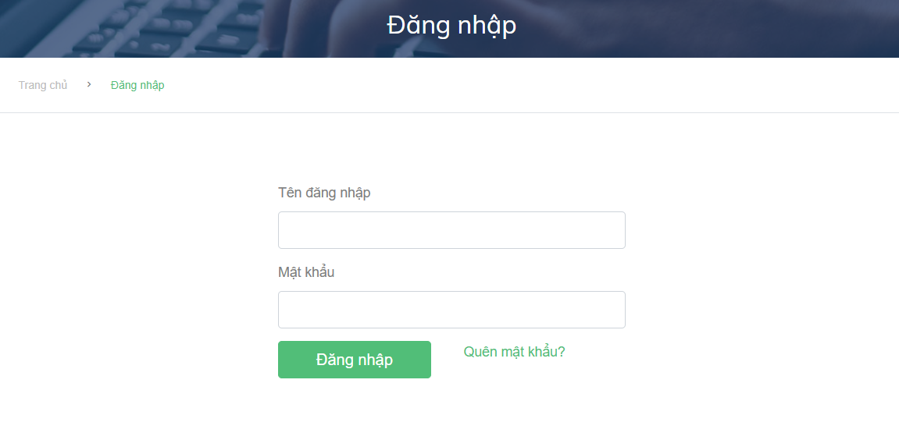

|  |  |  |
| --- | --- | --- |
| **Field Name** | **Field Type** | **Description** |
| username | text | Fill username to login |
| password | text | Fill password to login |
| Đăng nhập | button | Click to login account |
| Quên mật khẩu ? | link | Click to find password |

### 2.3 Forgot password

This screen allows show input email for account you want to find account

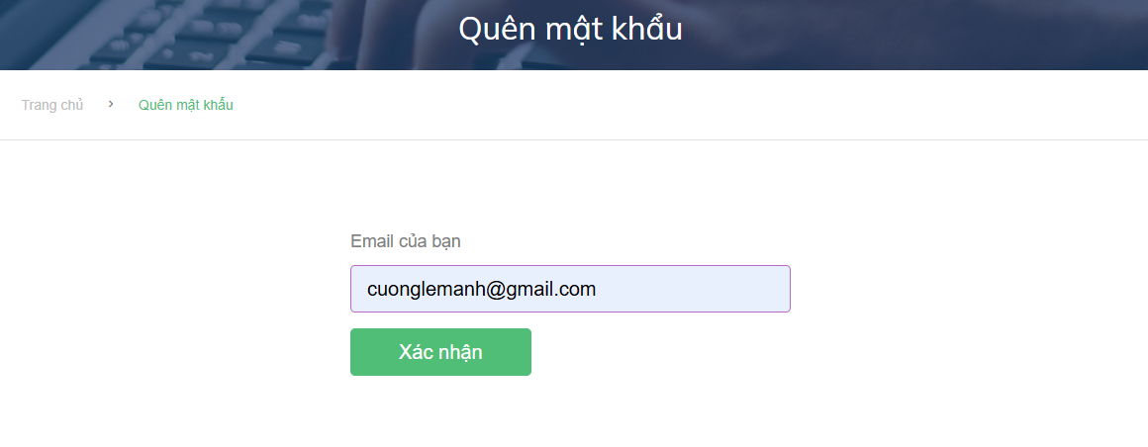

This screen allows show code for verification

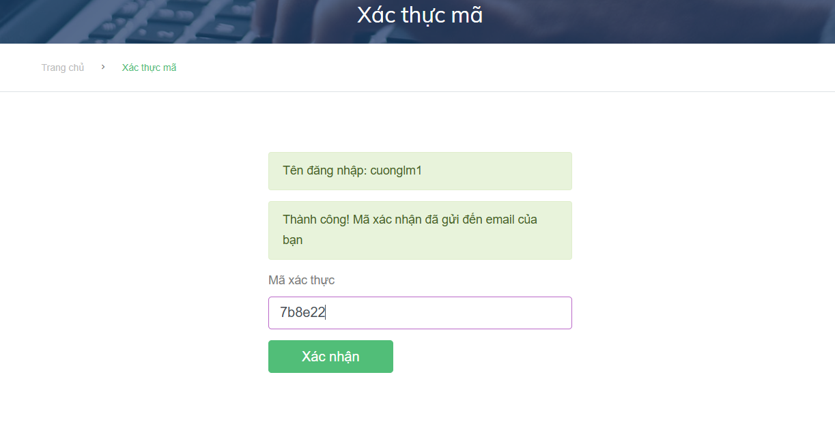

This screen allows show new password you want to set

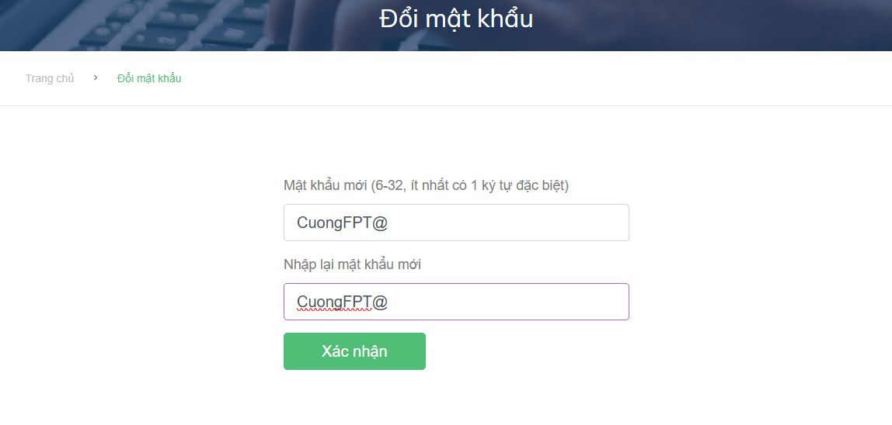

|  |  |  |
| --- | --- | --- |
| **Field Name** | **Field Type** | **Description** |
| email | text | Input email |
| verification code | text | Input code for verify |
| phone | text | Input phone number |
| new password | password | input password |
| re-new password | password | input password again to confirm |
| Xác nhận | button | Confirm to next steps |

### 2.4 Change password

This screen allows show input email for account you want to find account



|  |  |  |
| --- | --- | --- |
| **Field Name** | **Field Type** | **Description** |
| email | text | Input email |
| verification code | text | Input code for verify |
| phone | text | Input phone number |
| new password | password | input password |
| re-new password | password | input password again to confirm |
| Xác nhận | button | Confirm to next steps |

## 3. Manage course

### 3.1 Course detail

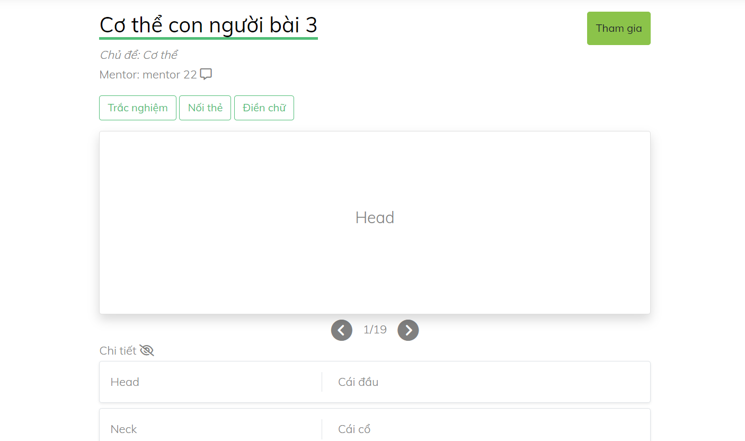

|  |  |  |
| --- | --- | --- |
| **Field Name** | **Field Type** | **Description** |
| Tham gia | Button | Accept user enroll/unenroll the course |
| Trắc nghiệm | HyperLink | Redirect to practice screen |
| Nối thẻ | HyperLink | Redirect to practice screen |
| Điền chữ | HyperLink | Redirect to practice screen |
| Icon message | Hyperlink | Redirect to send message screen |
| Icon next | Button | Next the flashcard |
| Icon back | Button | Back the flashcard |
| Icon eye | Button | Show/Hide list of flashcard |

### 3.2 View course by search and filter category

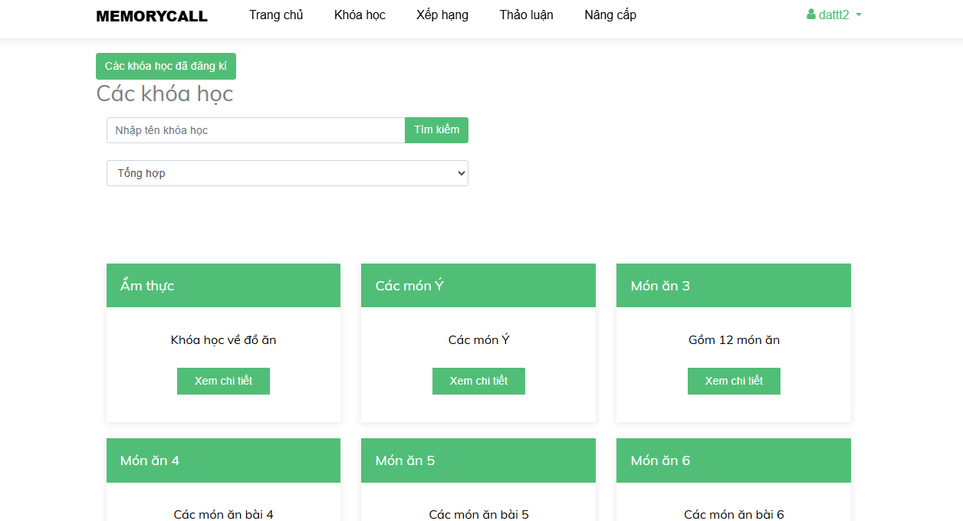

|  |  |  |
| --- | --- | --- |
| **Field Name** | **Field Type** | **Description** |
| Trang chủ | HyperLink | Redirect to homepage screen |
| Khóa học | HyperLink | Redirect to view course screen |
| Xếp hạng | HyperLink | Redirect to top ranking screen |
| Thảo luận | HyperLink | Redirect to discussion screen |
| Nâng cấp | Hyperlink | Redirect to upgrade account screen |
| Các khóa học đã đăng kí | HyperLink | Back to courses enrolled screen |
| Các khóa học | text | Description |
| Nhập tên khóa học | Text | Search courses by name |
| Tìm Kiếm | Button | Search button |
| Thể loại | Text | List categories of course |
| Cơ thể | Check box | Category of course |
| Quần áo | Check box | Category of course |
| Ẩm thực | Check box | Category of course |
| Động vật | Check box | Category of course |
| Thiên nhiên | Check box | Category of course |
| Ẩm thực | Text | Name of course |
| Khóa học về đồ ăn | Text | Description of course |
| Xem chi tiết | HyperLink | Redirect to course details screen |

### 3.3 View course by staff name

|  |  |  |
| --- | --- | --- |
| **Field Name** | **Field Type** | **Description** |
| Trang chủ | HyperLink | Redirect to homepage screen |
| Khóa học | HyperLink | Redirect to view course screen |
| Xếp hạng | HyperLink | Redirect to top ranking screen |
| Thảo luận | HyperLink | Redirect to discussion screen |
| Nâng cấp | Hyperlink | Redirect to upgrade account screen |
| Vai trò | Text | Role of user |
| Tên người dùng | Text | Name of user |
| Giới tính | Text | Gender of user |
| Ngày sinh | Text | Date of birth user |
| Số điện thoại | Text | Phone number of user |
| Email | Text | Email of user |
| Ẩm thực | Text | Name of course |
| Khóa học về đồ ăn | Text | Description of course |
| Xem chi tiết | HyperLink | Redirect to course details screen |

### 3.4 View course enrolled

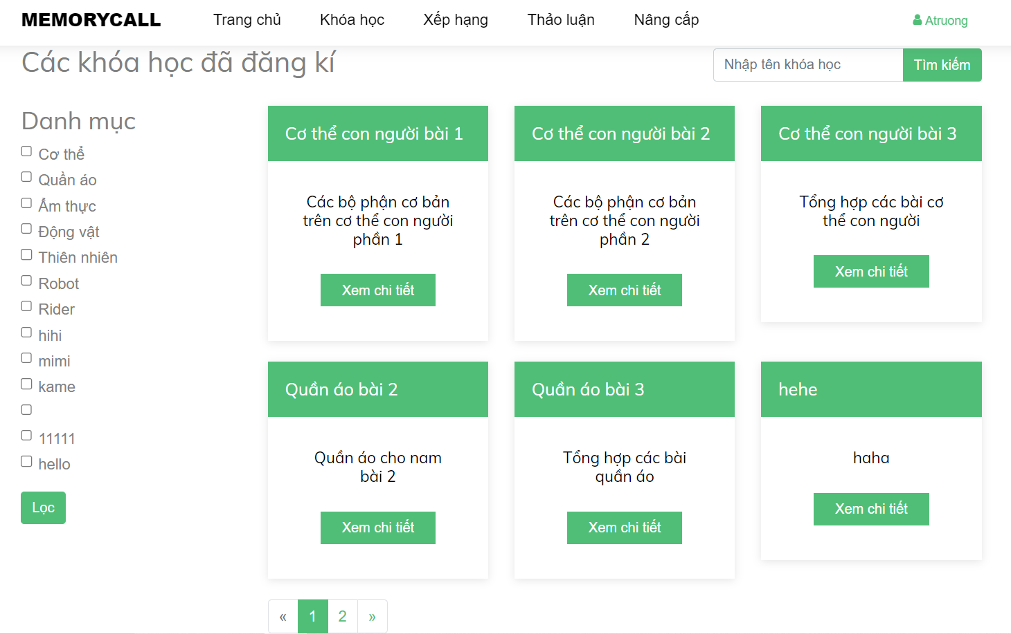

|  |  |  |
| --- | --- | --- |
| **Field Name** | **Field Type** | **Description** |
| Trang chủ | HyperLink | Redirect to homepage screen |
| Khóa học | HyperLink | Redirect to view course screen |
| Xếp hạng | HyperLink | Redirect to top ranking screen |
| Thảo luận | HyperLink | Redirect to discussion screen |
| Nâng cấp | Hyperlink | Redirect to upgrade account screen |
| Tìm kiếm | Button | Search course by name course |
| Lọc | Button | Filter course by category |
| 1,2 | Button | Paging course |
| Cơ thể con người bài 1 | Text | Name of course |
| Các bộ phận trên cơ thể con người bài 1 | Text | Description of course |
| Xem chi tiết | HyperLink | Redirect to course enrolled details screen |

### 3.5 View course studying

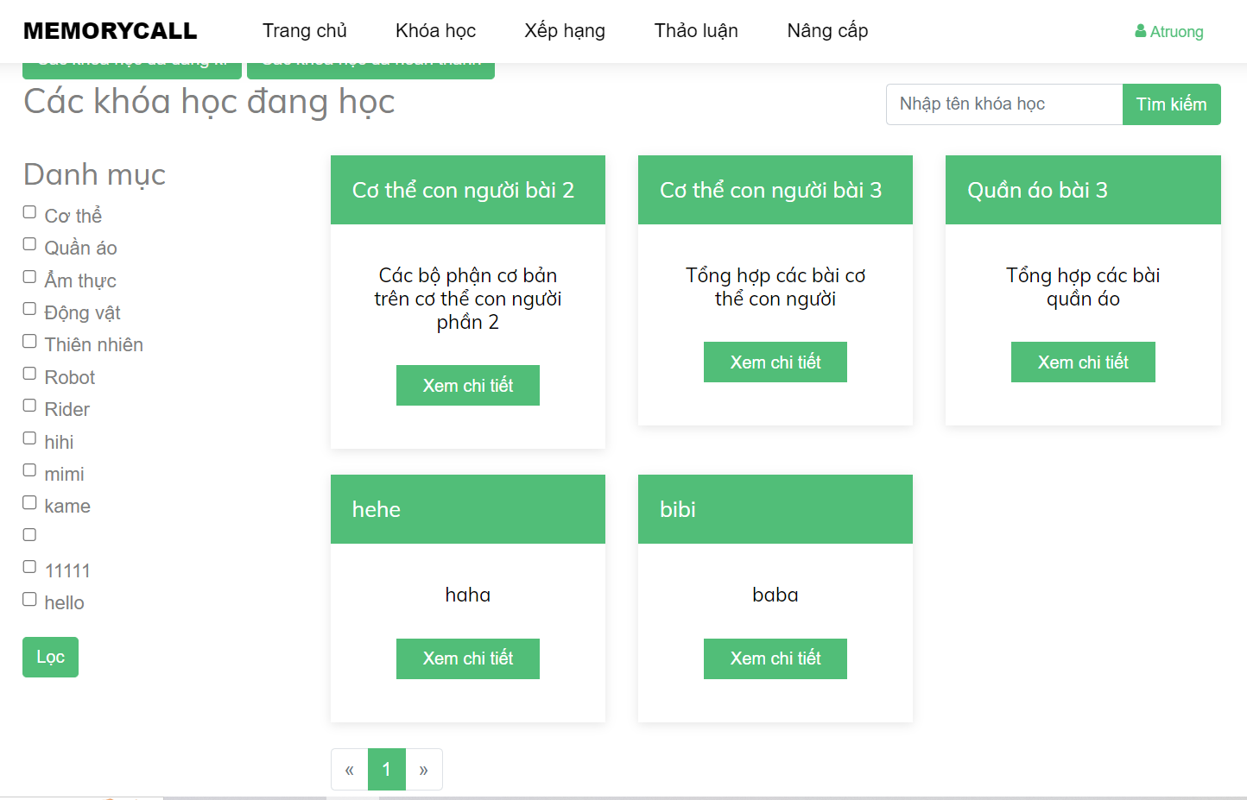

|  |  |  |
| --- | --- | --- |
| **Field Name** | **Field Type** | **Description** |
| Trang chủ | HyperLink | Redirect to homepage screen |
| Khóa học | HyperLink | Redirect to view course screen |
| Xếp hạng | HyperLink | Redirect to top ranking screen |
| Thảo luận | HyperLink | Redirect to discussion screen |
| Nâng cấp | Hyperlink | Redirect to upgrade account screen |
| Tìm kiếm | Button | Search course by name course |
| Lọc | Button | Filter course by category |
| 1,2 | Button | Paging course |
| Cơ thể con người bài 2 | Text | Name of course |
| Các bộ phận trên cơ thể con người bài 2 | Text | Description of course |
| Xem chi tiết | HyperLink | Redirect to course enrolled details screen |

### 3.6 View course completed

This screen allows viewing all course completed.

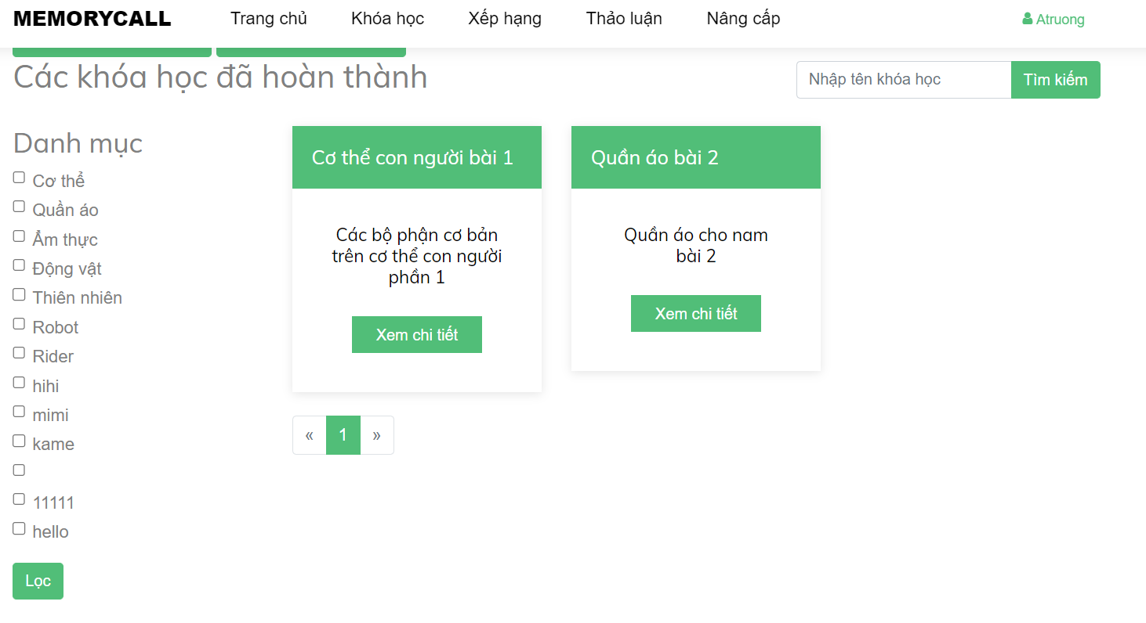

|  |  |  |
| --- | --- | --- |
| **Field Name** | **Field Type** | **Description** |
| Trang chủ | HyperLink | Redirect to homepage screen |
| Khóa học | HyperLink | Redirect to view course screen |
| Xếp hạng | HyperLink | Redirect to top ranking screen |
| Thảo luận | HyperLink | Redirect to discussion screen |
| Nâng cấp | Hyperlink | Redirect to upgrade account screen |
| Tìm kiếm | Button | Search course by name course |
| Lọc | Button | Filter course by category |
| 1,2 | Button | Paging course |
| Cơ thể con người bài 1 | Text | Name of course |
| Các bộ phận trên cơ thể con người bài 1 | Text | Description of course |
| Xem chi tiết | HyperLink | Redirect to course enrolled details screen |

### 3.7 Add course

This screen allows staff add course.

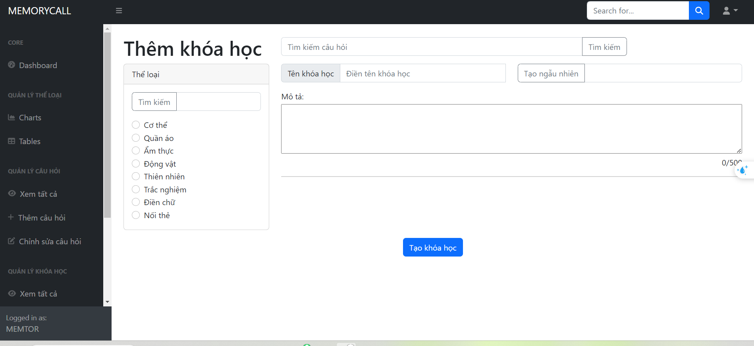

|  |  |  |
| --- | --- | --- |
| **Field Name** | **Field Type** | **Description** |
| Tạo khóa học | Button | Submit form |
| Thể loại | CheckBox | Choose category |
| Tên khóa học | Text(50 character) | Enter course’s name |
| Tạo ngẫu nhiên | Text(Number) | Enter number of flashcard random to course |
| Tìm kiếm | Text | Search name of question |
| Mô tả | Text(500) | Enter description |

## 4. Manage flashcard

### 4.1 Add flashcard

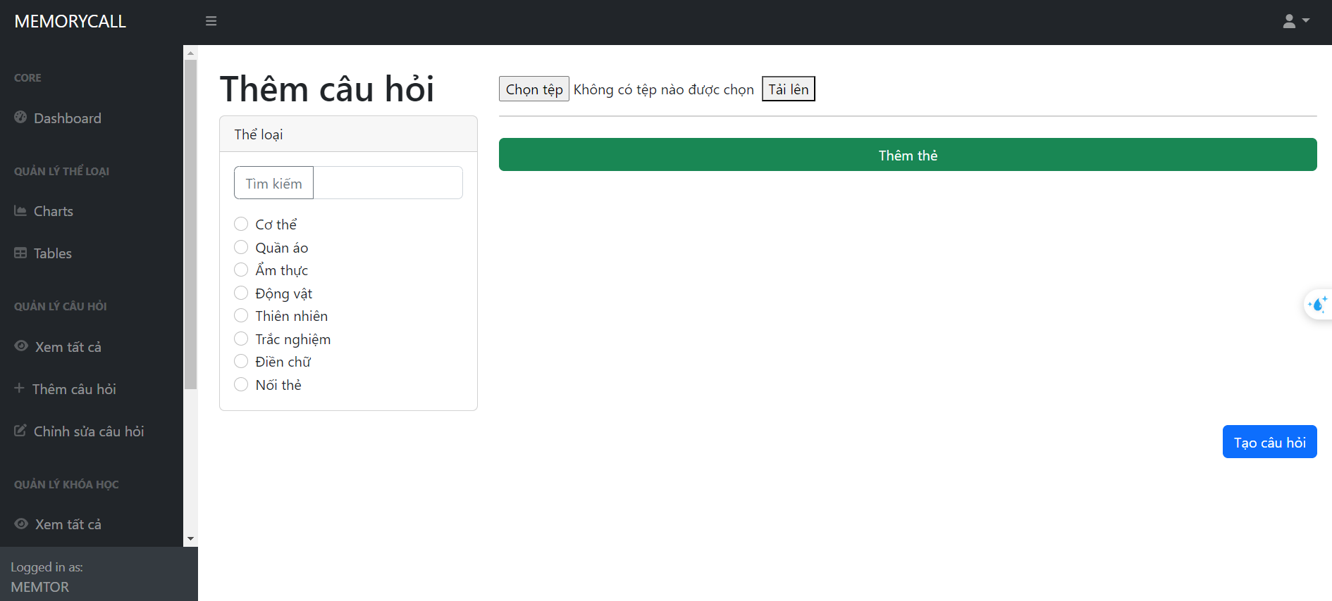

|  |  |  |
| --- | --- | --- |
| **Field Name** | **Field Type** | **Description** |
| Tạo câu hỏi | Button | Submit form |
| Thể loại | CheckBox | Choose category |
| Thêm thẻ | Button | Add new empty flashcard |
| Chọn tệp | File | Get file in local |
| Tải lên | button | Show all data in file |
| Question | Text | Enter question |
| Answer | Text | Enter answer |

### 4.2 View and Search and Filter flashcard

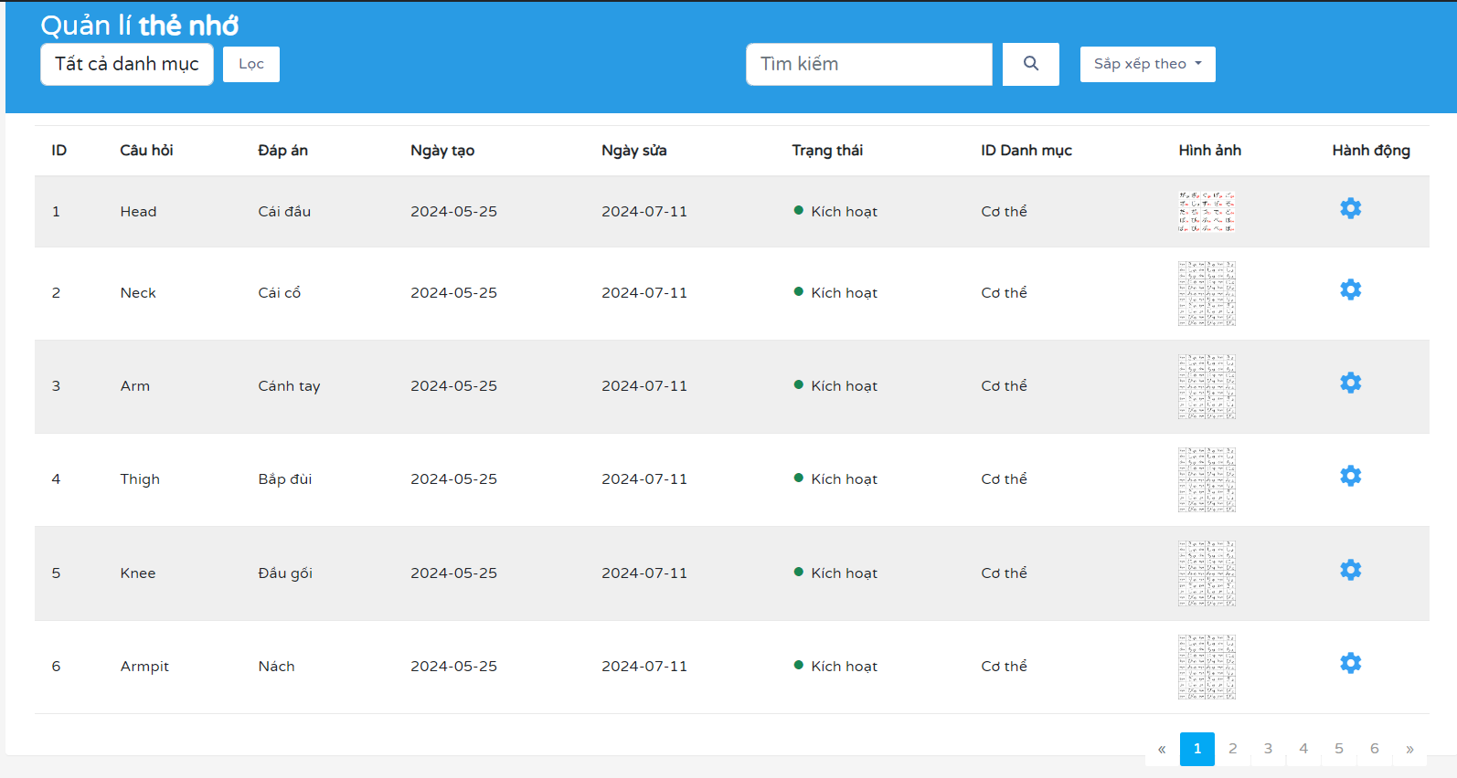

|  |  |  |
| --- | --- | --- |
| **Field Name** | **Field Type** | **Description** |
| Tìm kiếm | Text | search Flashcard |
| Biểu tượng bánh răng | Hyperlink | redirect to updatescreen |
| 1,2 | Button | Paging |
| Lọc | Button | Filter flashcard by category |
| Sắp xếp theo | Choose | Sort by date new/old |

### 4.3 Update flashcard

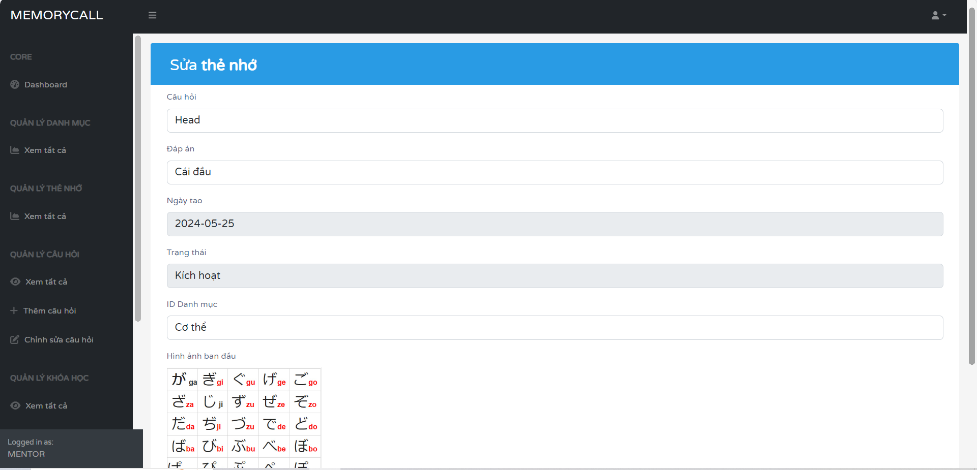

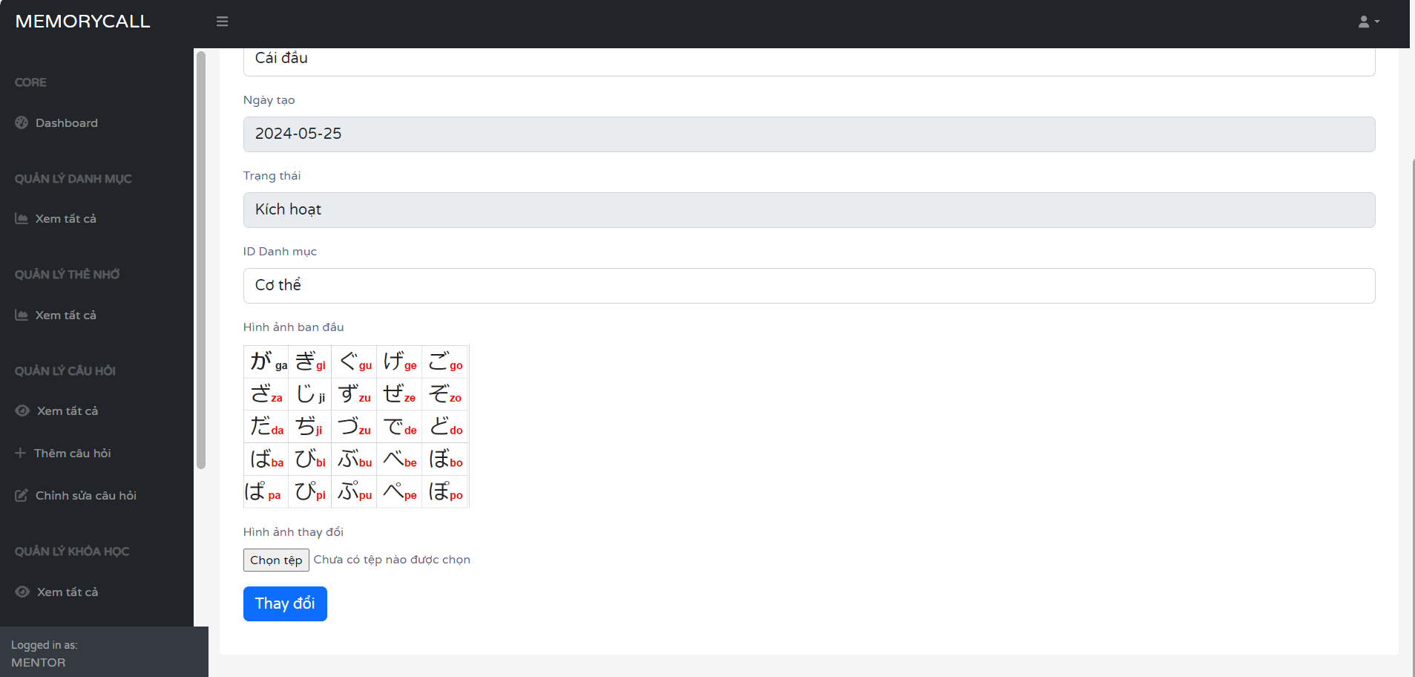

|  |  |  |
| --- | --- | --- |
| **Field Name** | **Field Type** | **Description** |
| Câu hỏi | Text | question flashcard |
| Đáp án | Text | answer flashcard |
| Ngày tạo | Text | date update category |
| Trạng thái | Text | active |
| Thay đổi | submit | update flashcard |
| ID danh mục | Choose | name category flashcard |
| Chọn tệp | Button | choose file update |

## 5. Manage category

### 5.1 View and search category

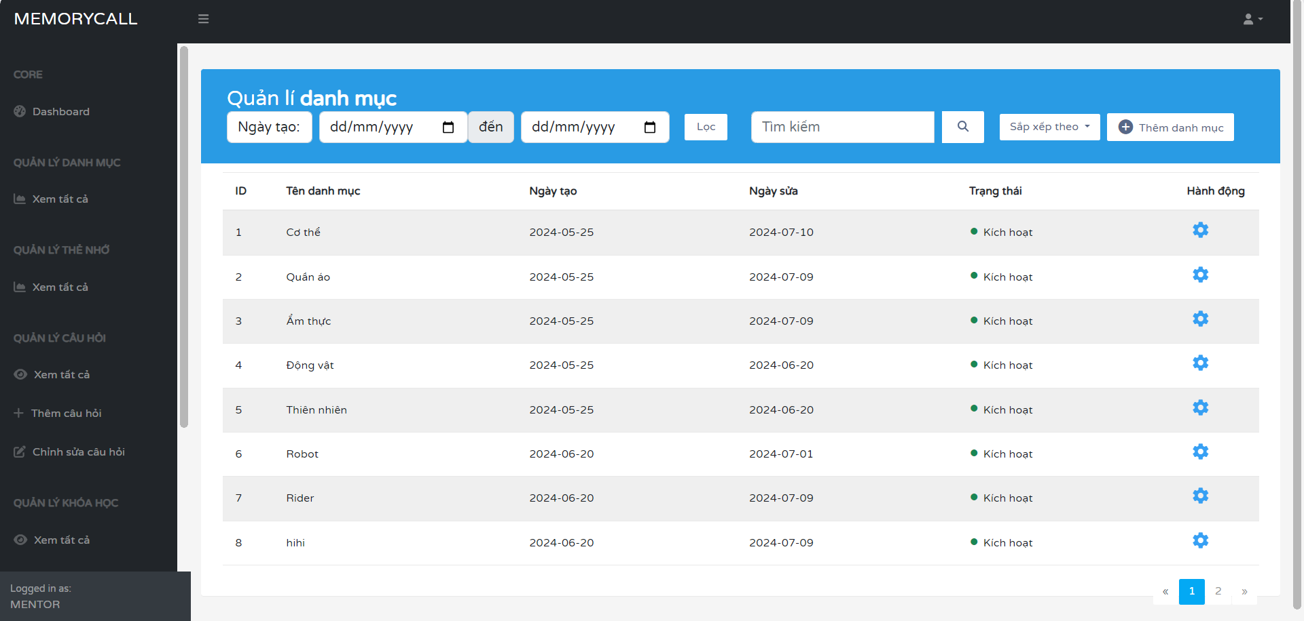

|  |  |  |
| --- | --- | --- |
| **Field Name** | **Field Type** | **Description** |
| Tìm kiếm | Text | search category |
| Thêm danh mục | Hyperlink | redirect to create screen |
| Biểu tượng bánh răng | Hyperlink | redirect to updatescreen |
| Lọc | Button | Filter category by date created or date updated |
| Sắp xếp theo | Choose | Sort by date new/old |

### 5.2 Update category

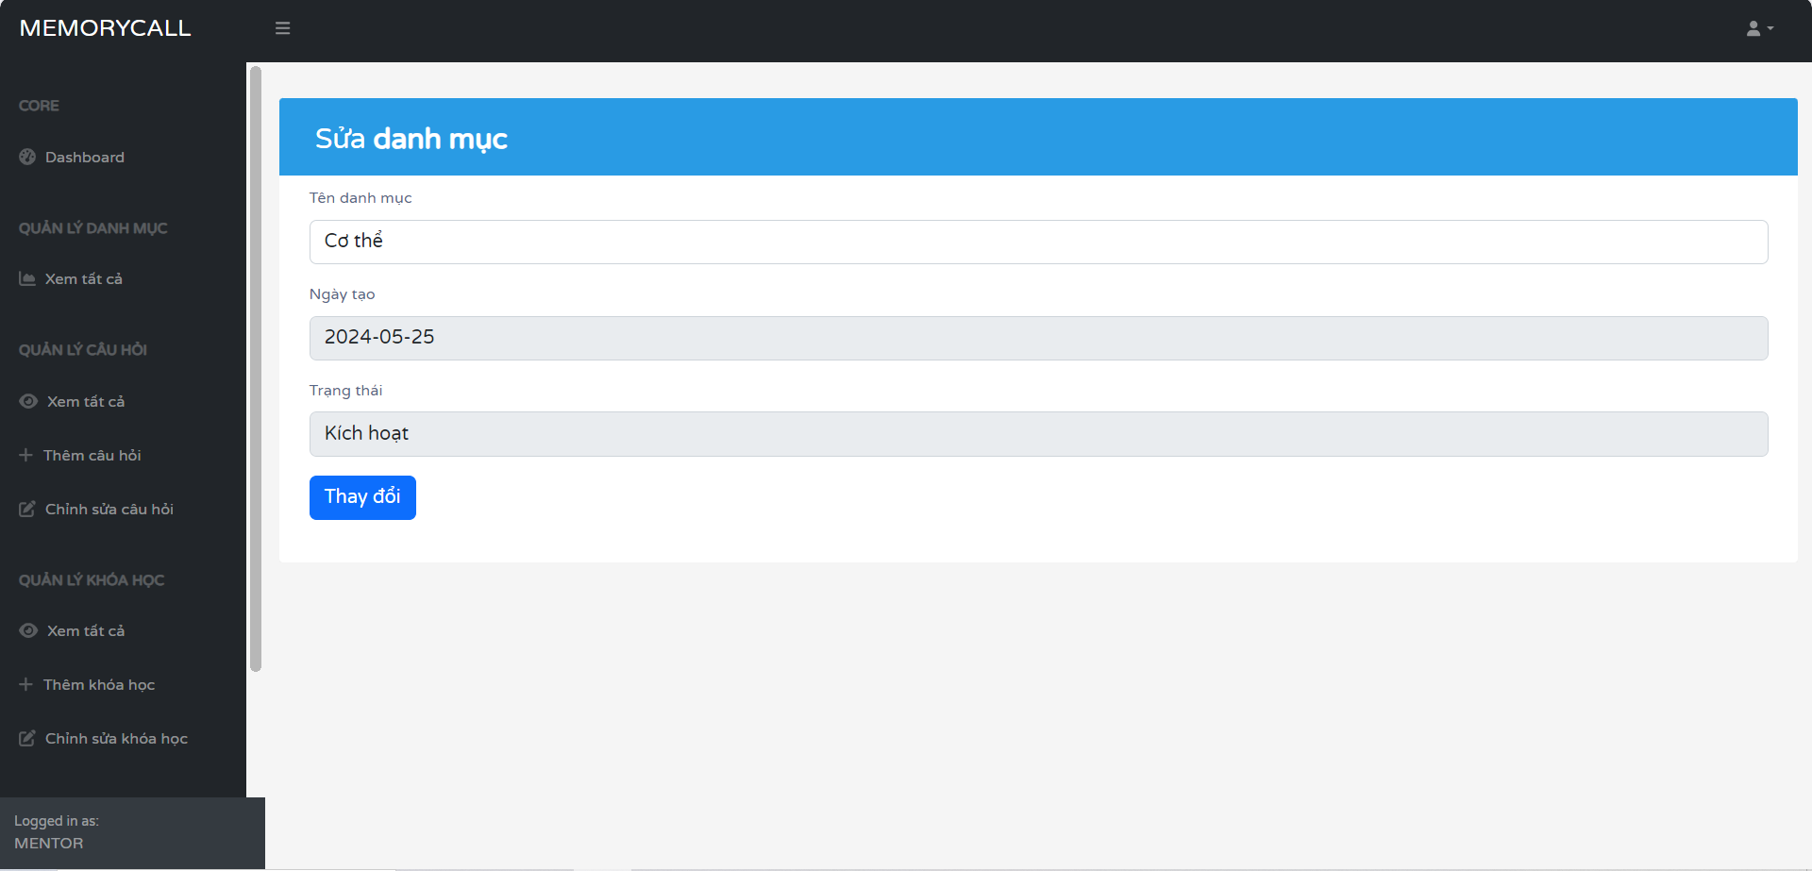

|  |  |  |
| --- | --- | --- |
| **Field Name** | **Field Type** | **Description** |
| Tên danh mục | Text | name category |
| Ngày tạo | Text | date update category |
| Trạng thái | Text | active |
| Thay đổi | submit | update category |

### 5.3 Create category

|  |  |  |
| --- | --- | --- |
| **Field Name** | **Field Type** | **Description** |
| Tên danh mục | Text | name category |
| Thêm | submit | create category |
| Trạng thái | choose | active |

## 6. Manage discussions

### 6.1 View all discussion forum

Users can browse all discussion forums available on the platform

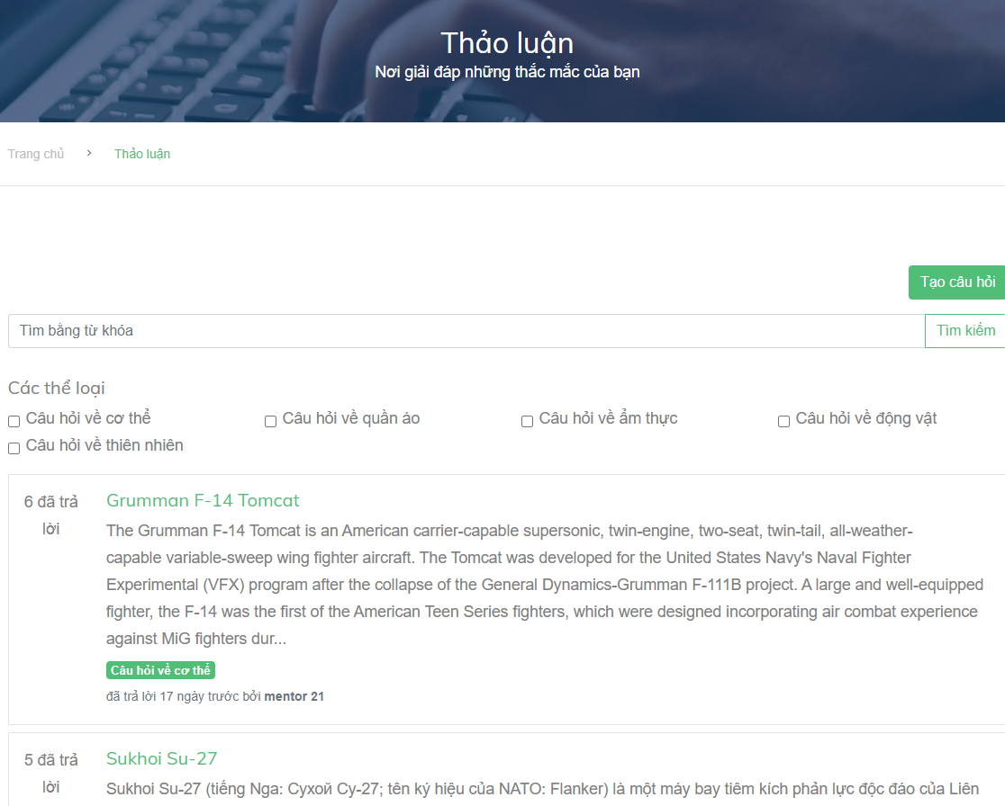

|  |  |  |
| --- | --- | --- |
| **Field Name** | **Field Type** | **Description** |
| Tạo câu hỏi | button | Create new question |
| search | text | Input search keywords |
| Tìm kiếm | button | Search questions by keywords or categories |
| categories | checkbox | check the category you want to search |
| title | text | Title of the question |
| content | text | Content of the question |

### 6.2 Search discussion

Users can search discussion by keywords on the platform



|  |  |  |
| --- | --- | --- |
| search | text | Input search keywords |
| Tìm kiếm | button | Search questions by keywords or categories |

### 6.3 Filter discussion

Users can can choose the categories they want to see on the platform



|  |  |  |
| --- | --- | --- |
| categories | checkbox | check the category you want to search |
| Tìm kiếm | text | Search questions by keywords or categories |

### 6.4 Comment

Users can comment the posts in discussions

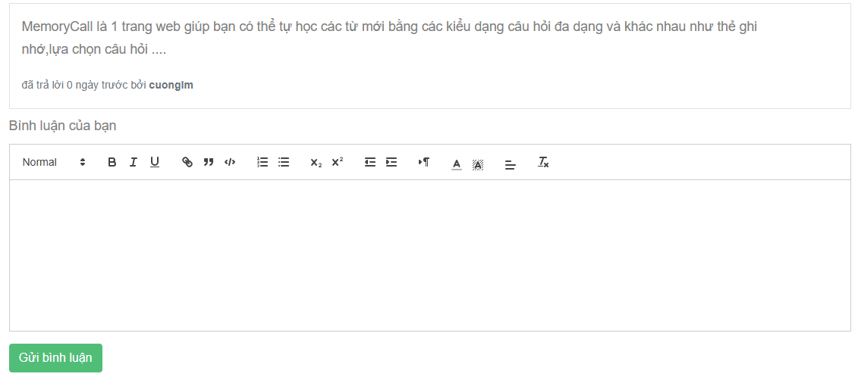

|  |  |  |
| --- | --- | --- |
| **Field Name** | **Field Type** | **Description** |
| content | text | Content of the comment |
| created-at | text | Show the date the comment created |
| comment-form | form | Input comment |
| Gửi bình luận | button | Post your comment in discussion |

## 7. Manage account

### 7.1 View profile

Users can see their profile information

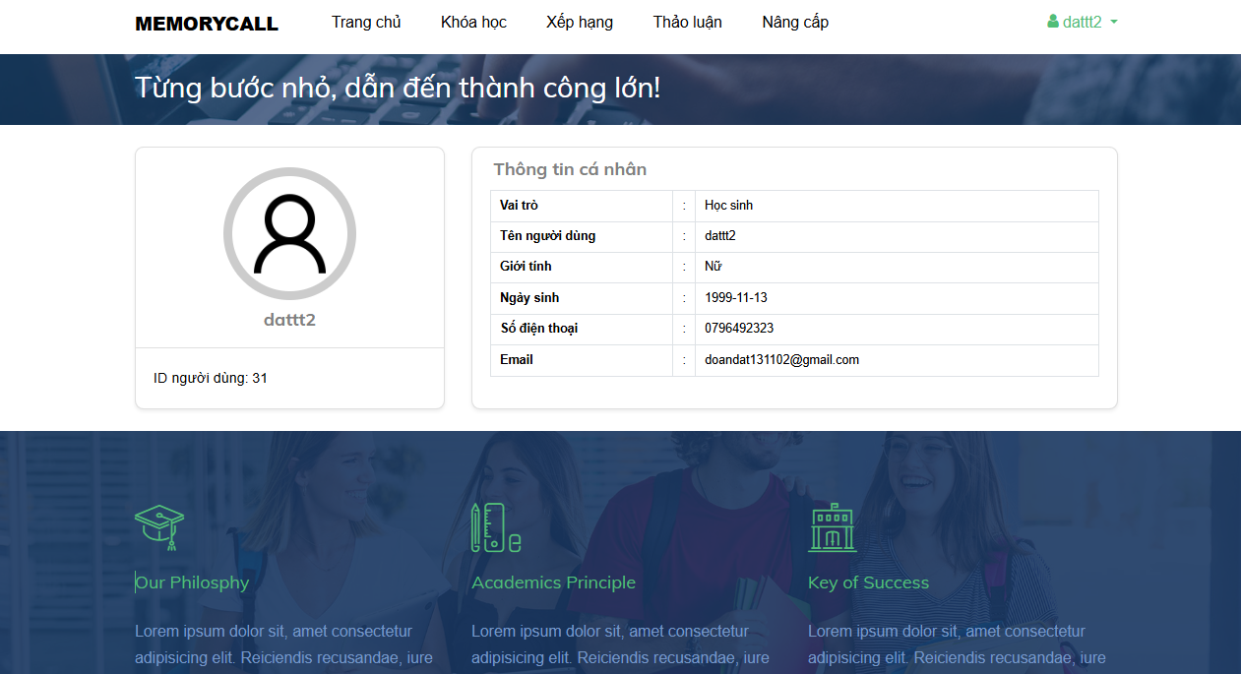

|  |  |  |
| --- | --- | --- |
| **Field Name** | **Field Type** | **Description** |
| Memorycall | HyperLink | Redirect to landing page |
| Trang chủ | HyperLink | Redirect to homepage |
| Khóa học | HyperLink | Redirect to course |
| Xếp hạng | HyperLink | Redirect to list of student on top |
| Thảo luận | Hyperlink | Redirect to discuss page |
| Nâng cấp | Hyperlink | Redirect to upgrade account page |
| dat | Hyperlink | Redirect to user profile page |
| Vai trò | text | Role of user |
| Tên người dùng | text | Name of user |
| Giới tính | text | Gender of user |
| Ngày sinh | text | User’s date of birth |
| Số điện thoại | text | Phone number of user |
| Email | text | Email of user |

### 7.2 Update profile

User update their profile information

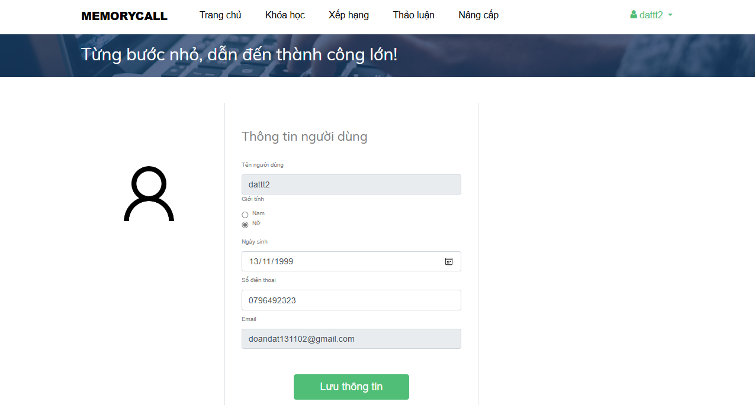

|  |  |  |
| --- | --- | --- |
| **Field Name** | **Field Type** | **Description** |
| Memorycall | HyperLink | Redirect to landing page |
| Trang chủ | HyperLink | Redirect to homepage |
| Khóa học | HyperLink | Redirect to course |
| Xếp hạng | HyperLink | Redirect to list of student on top |
| Thảo luận | Hyperlink | Redirect to discuss page |
| Nâng cấp | Hyperlink | Redirect to upgrade account page |
| dat | Hyperlink | Redirect to user profile page |
| Tên người dùng | text | Input name of user |
| Giới tính | radio | Select gender of user |
| Ngày sinh | date | Input user’s date of birth |
| Số điện thoại | text | Input phone number of user |
| Email | text | Input email of user |
| Lưu thông tin | button | Save new profile of user |

## 8. Manage top ranking

### 8.1 View top ranking

View top ranking points of users

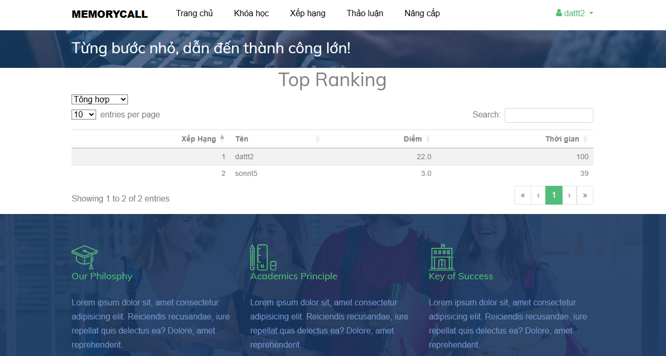

|  |  |  |
| --- | --- | --- |
| **Field Name** | **Field Type** | **Description** |
| Memorycall | HyperLink | Redirect to landing page |
| Trang chủ | HyperLink | Redirect to homepage |
| Khóa học | HyperLink | Redirect to course |
| Xếp hạng | HyperLink | Redirect to list of student on top |
| Thảo luận | Hyperlink | Redirect to discuss page |
| Nâng cấp | Hyperlink | Redirect to upgrade account page |
| dattt2 | Hyperlink | Dropdown user menu |
| Tổng hợp/Trắc nghiệm/Điền chữ/Nối thẻ | option | Type practice of quizzes |
| Xếp hạng | text | Rank of user |
| Tên | text | Name of user |
| Điểm | text | Point of user practice |
| Thời gian | text | Time of use practice |

## 9. Manage admin

### 9.1 View all staff

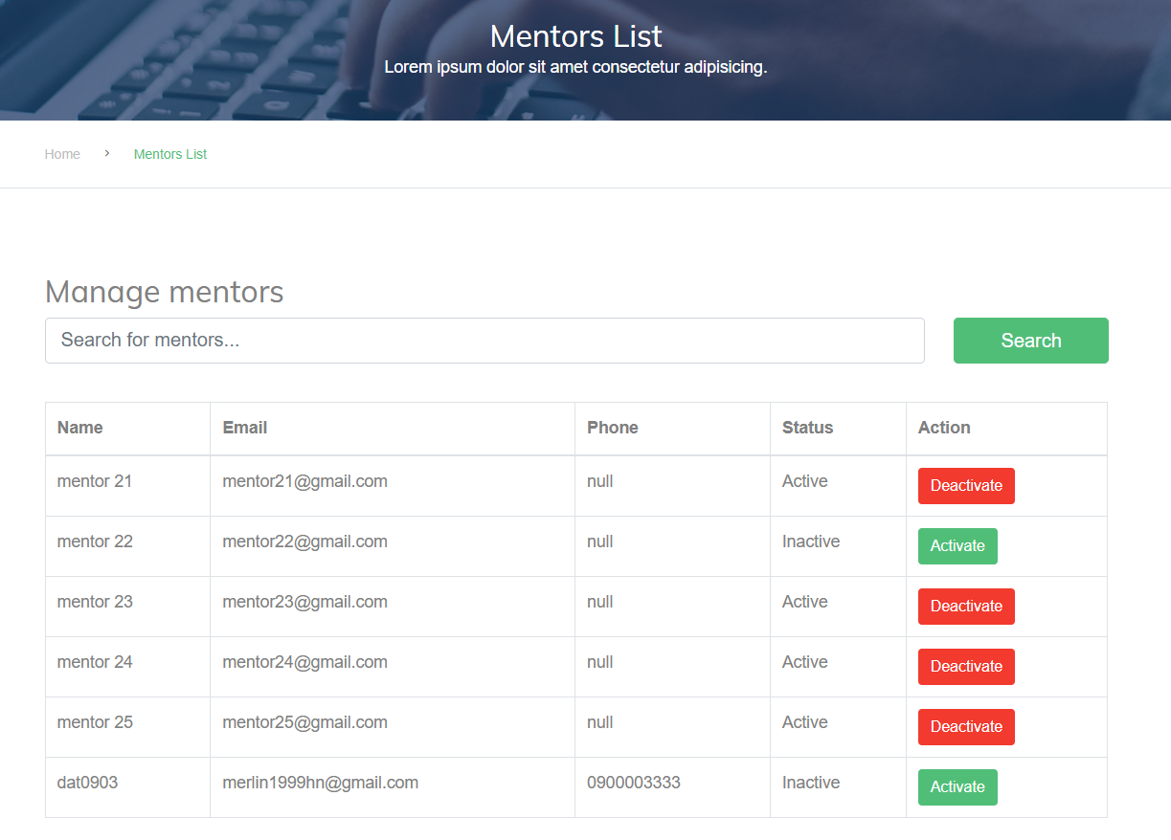

|  |  |  |
| --- | --- | --- |
| **Field Name** | **Field Type** | **Description** |
| search | textbox | Fill the keywords you want to search |
| Search | button | Click to search by keywords |
| name | text | name of staff |
| email | text | email of staff |
| phone | text | phone of staff |
| status | text | status of staff |
| action | button | click to inactive or active staff |

### 9.2 Search staff

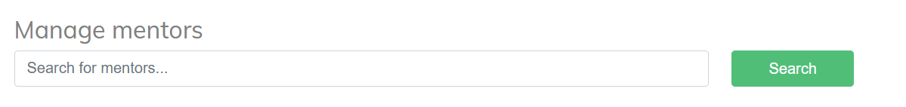

|  |  |  |
| --- | --- | --- |
| **Field Name** | **Field Type** | **Description** |
| search | textbox | Fill the keywords you want to search |
| Search | button | Click to search by keywords |

### 9.3 Add staff

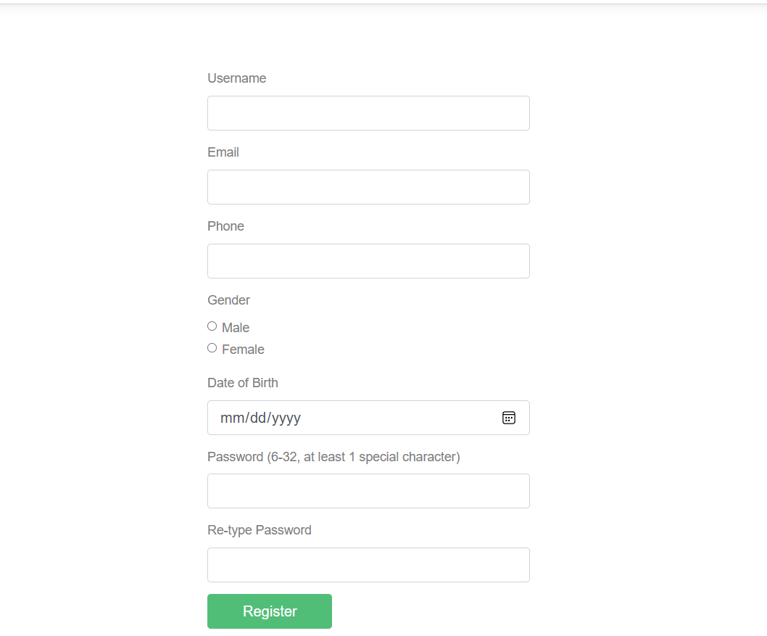

|  |  |  |
| --- | --- | --- |
| **Field Name** | **Field Type** | **Description** |
| username | text | Input username |
| email | email | Input email to register |
| phone | text | Input phone number |
| gender | checkbox | Input gender by ticking the box |
| DOB | text | Input date of birth |
| password | password | input password |
| re-password | password | input password again to confirm |
| Đăng ký | button | click to register the user |

### 9.4 Active/Deactive staff

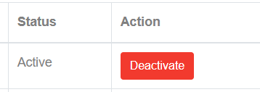

|  |  |  |
| --- | --- | --- |
| **Field Name** | **Field Type** | **Description** |
| status | textbox | status of staff |
| action | button | click to inactive or active staff |

## 10. Manage course

### 10.1 View course by staff

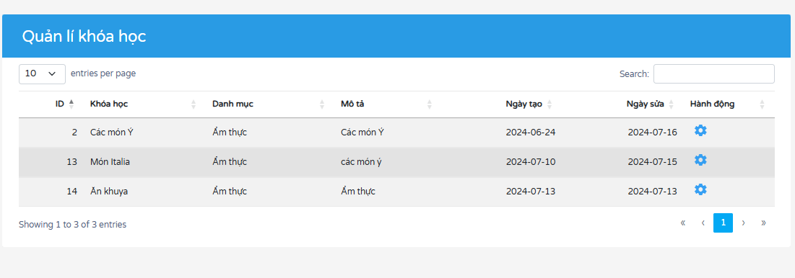

|  |  |  |
| --- | --- | --- |
| **Field Name** | **Field Type** | **Description** |
| 10 | option | Length of courses in page |
| ID | button | Sort by course_id |
| Khóa học | button | Sort by course_name |
| Danh mục | button | Sort by categody_name |
| Mô tả | button | Sort by description |
| Ngày tạo | button | Sort bt created_at |
| Ngày sửa | button | Sort bt update_at |
| setting icon | HyperLink | Redirect to edit course screen |

### 10.2 Edit course

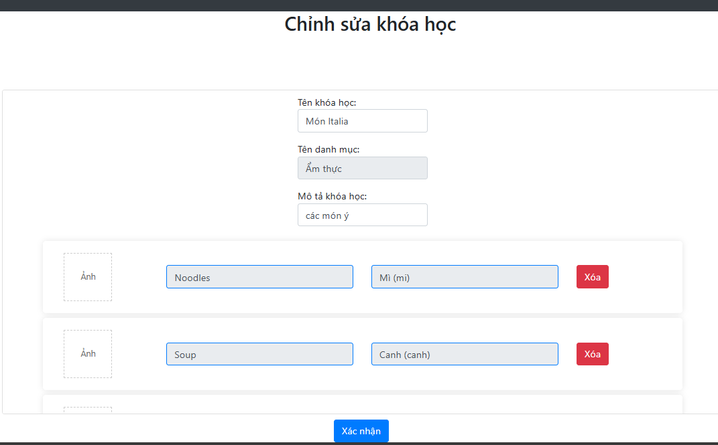

|  |  |  |
| --- | --- | --- |
| **Field Name** | **Field Type** | **Description** |
| Tên khóa học | text | Name of course |
| Tên danh mục | text | Name of category |
| Mô tả khóa học | text | Description of course |
| Ảnh | image | Image of quiz |
| Noodles | text | Question of quiz |
| Mì (mi) | text | Answer of quiz |
| Xóa | button | Delete quiz |
| Xác nhận | button | Submit update course |

## 11. Manage student

### 11.1 View course by staff

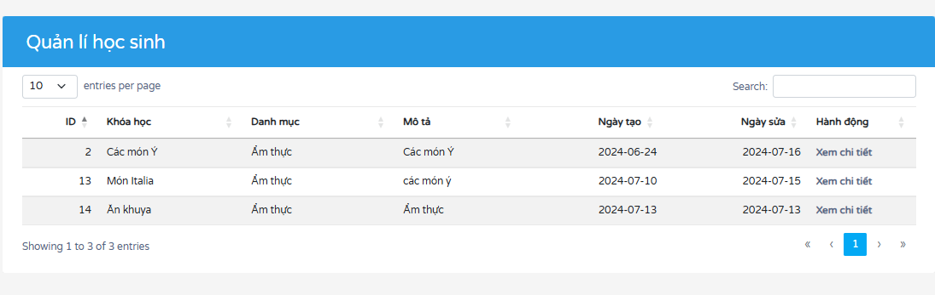

|  |  |  |
| --- | --- | --- |
| **Field Name** | **Field Type** | **Description** |
| 10 | option | Length of students in page |
| ID | button | Sort by course_id |
| Khóa học | button | Sort by course_name |
| Danh mục | button | Sort by categody_name |
| Mô tả | button | Sort by description |
| Ngày tạo | button | Sort bt created_at |
| Ngày sửa | button | Sort bt update_at |
| Xem chi tiết | HyperLink | Redirect to view student screen |

### 11.2 View student by class

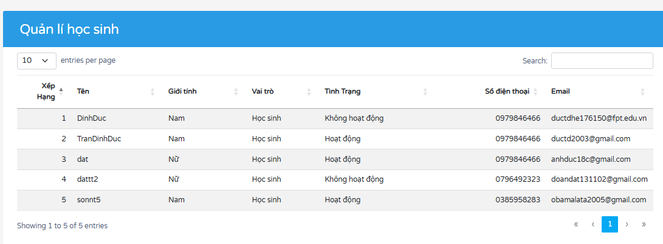

|  |  |  |
| --- | --- | --- |
| **Field Name** | **Field Type** | **Description** |
| 10 | option | Length of courses in page |
| Xếp hạng | button | Rank of students |
| Tên | button | Sort by name of students |
| Giới tính | button | Sort by gender |
| Vai trò | button | Sort by role |
| Tình trạng | button | Sort bt status |
| Số điện thoại | button | Sort bt phone |
| Email | HyperLink | Sort bt email |

## 12. Manage practice

### 12.1 Multiple choice

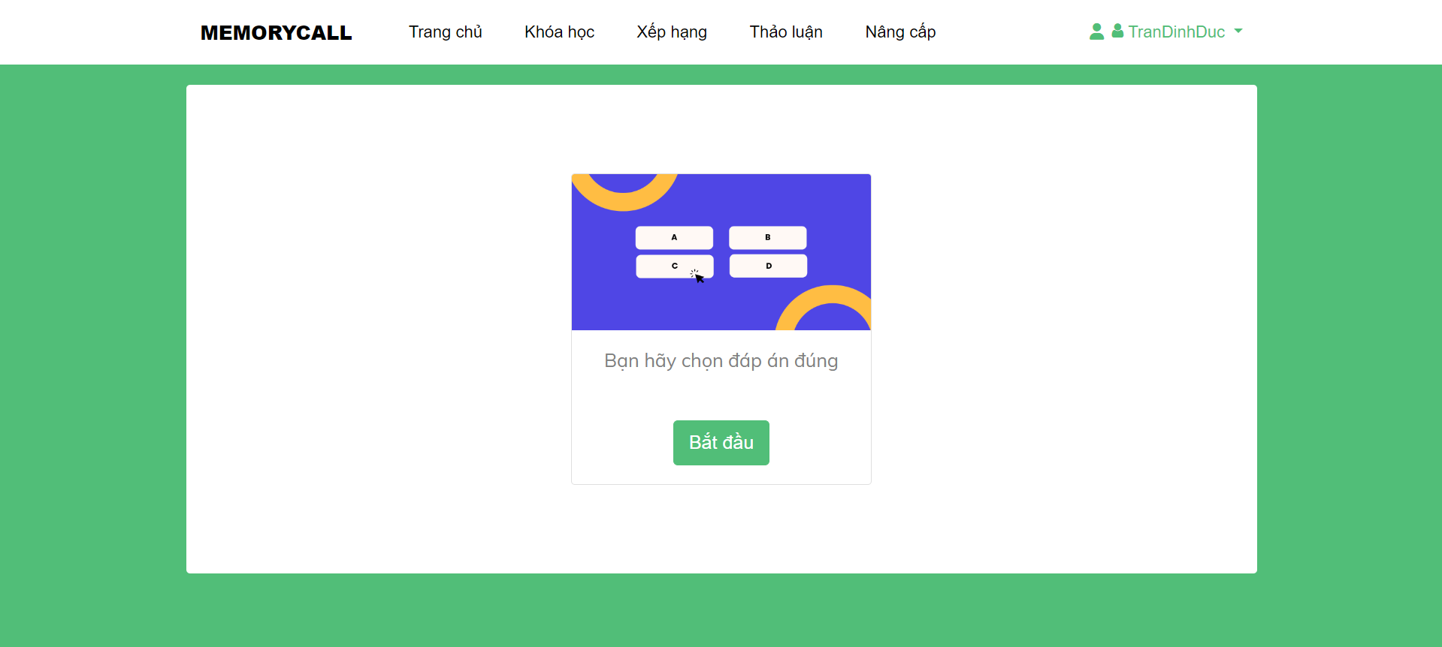

|  |  |  |
| --- | --- | --- |
| **Field Name** | **Field Type** | **Description** |
| Bắt đầu | Button | Open screen practice |

### 12.2 Result

|  |  |  |
| --- | --- | --- |
| **Field Name** | **Field Type** | **Description** |
| Học lại | Button | Practice again |
| Trờ về | Button | Back to course detail |

### 12.3 Fill in blank

|  |  |  |
| --- | --- | --- |
| **Field Name** | **Field Type** | **Description** |
| Bắt đầu | Button | Open screen practice |

|  |  |  |
| --- | --- | --- |
| **Field Name** | **Field Type** | **Description** |
| Xác nhận | Button | Confirm answer |
| _ | Input | Enter word |

### 12.4 Matching

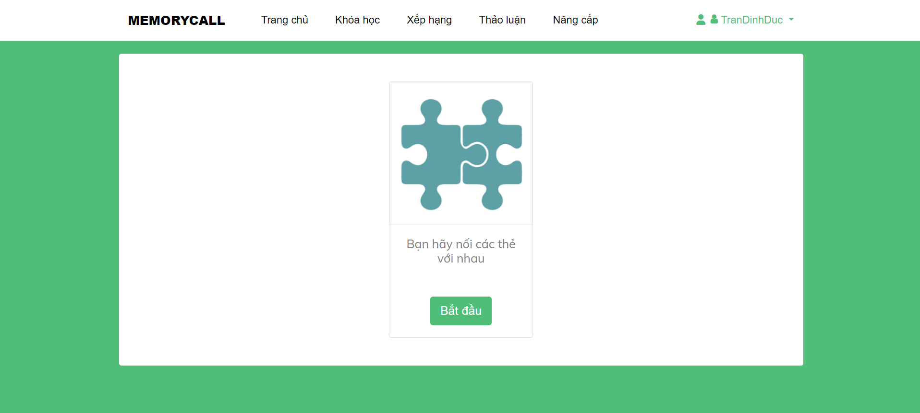

|  |  |  |
| --- | --- | --- |
| **Field Name** | **Field Type** | **Description** |
| Bắt đầu | Button | Start matching |
|  |  |  |

|  |  |  |
| --- | --- | --- |
| **Field Name** | **Field Type** | **Description** |
| Xác nhận | Button | Confirm answer |
|  |  |  |

## 13. Manage Statistic

### 13.1 Staff Dashboard

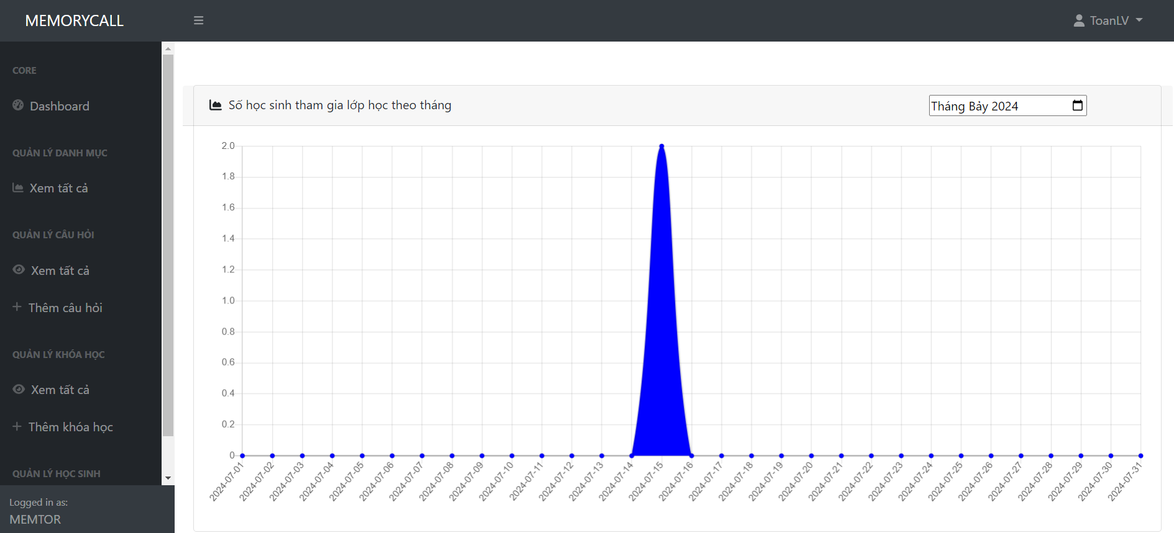

|  |  |  |
| --- | --- | --- |
| **Field Name** | **Field Type** | **Description** |
| date | Input | Enter date to filter |
|  |  |  |

### 13.2 Admin Dashboard

|  |  |  |
| --- | --- | --- |
| **Field Name** | **Field Type** | **Description** |
| date | Input | Enter date to filter |
|  |  |  |

# IV. Code Designs

## 1. Register

### 1.1 Class Diagram

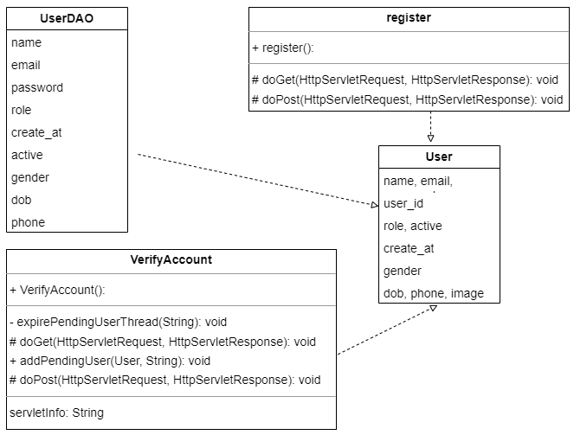

### 1.2 Sequence Diagram

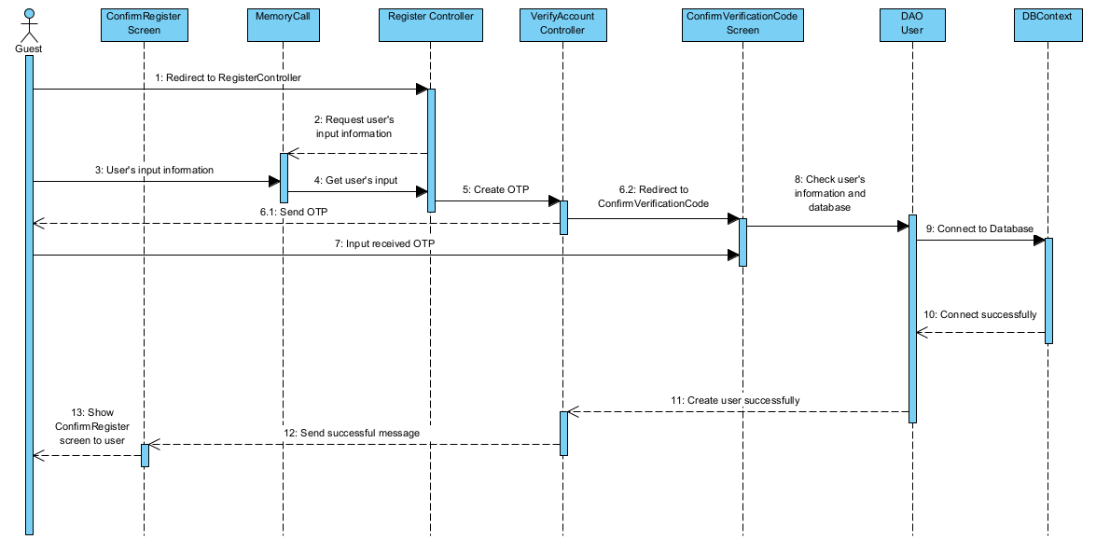

### 1.3 Database Queries

insert into [user]([name], email, [password], role, active, create_at, gender, dob, phone) values(?,?,?,?,?,?,?,?,?)

"select * from [user]"

select * from [user] where email = ?

select * from [user] where user_id = ?

select * from [user] where name = ?

## 2. Login

### 2.1 Class Diagram

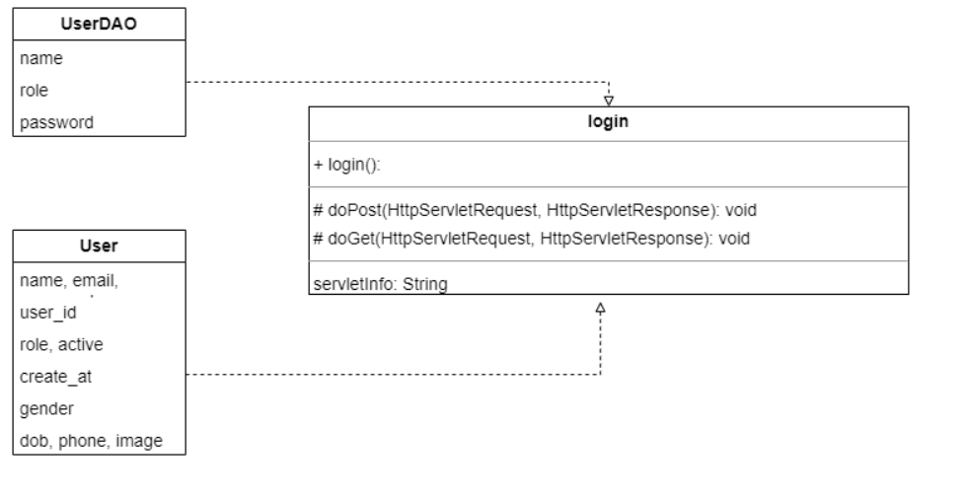

### 2.2 Sequence Diagram

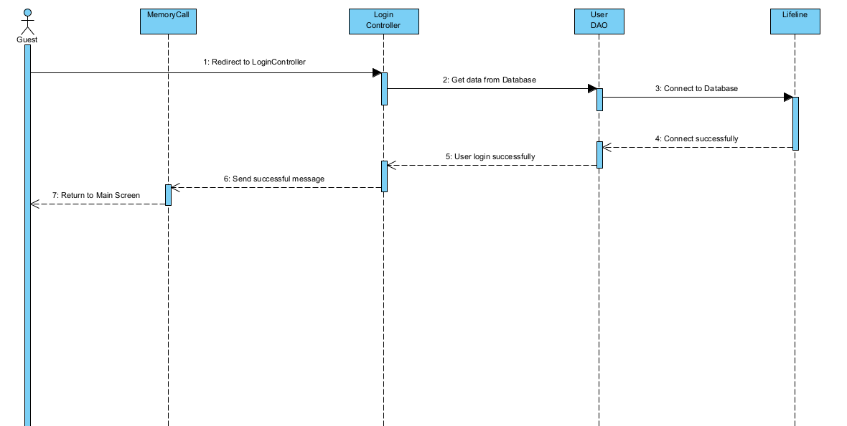

### 2.3 Database Queries

select * from [user] where name = ?

## 3. Forgot Password

### 3.1 Class Diagram

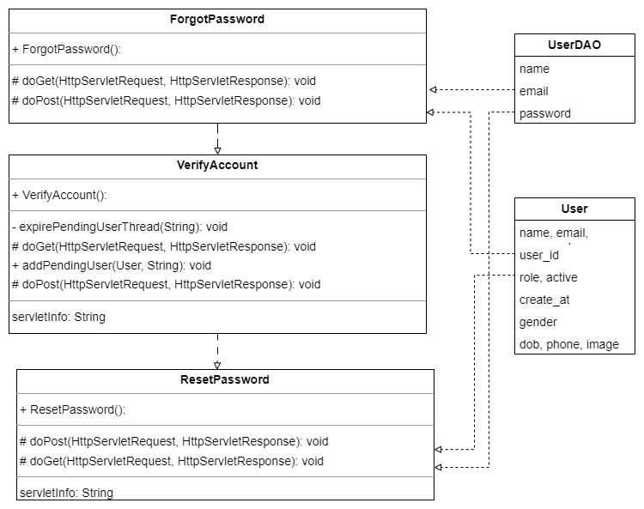

### 3.2 Sequence Diagram

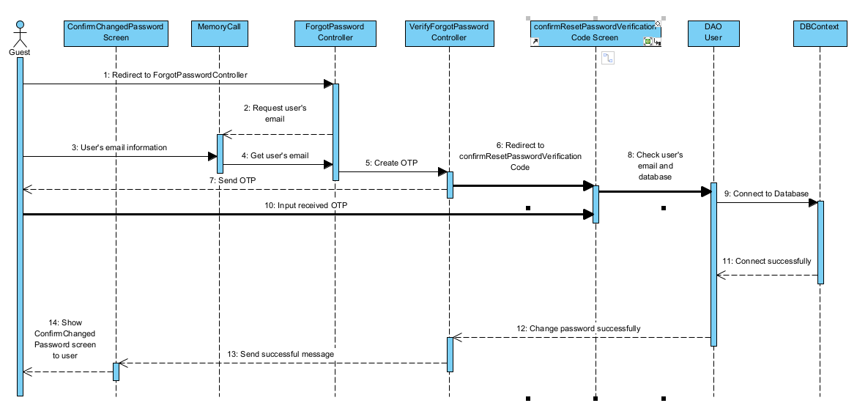

### 3.3 Database Queries

select * from [user] where email = ?

select * from [user] where user_id = ?

update [user] set [password] = ? where user_id = ?

## 4. Home Page

### 4.1 Class Diagram

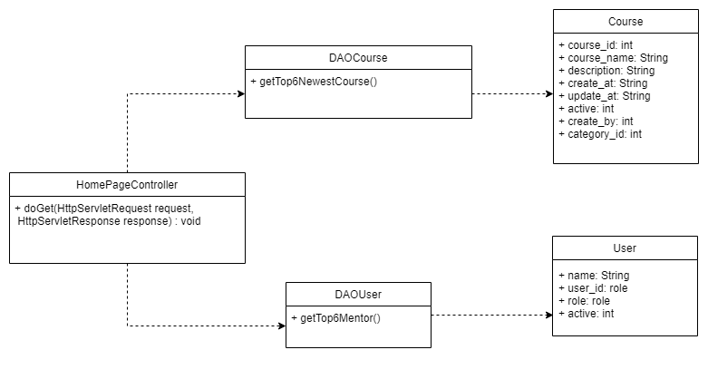

### 4.2 Sequence Diagram(s)

### 4.3 Database Queries

### 4.3.1 getTop6NewestCourse()

select top 6*

from course

order by create_at desc,newid();

### 4.3.1 getTop6NewestCourse()

select top6 u.name,u.user_id,u.role,count(c.couse_name) as total_courses

from [User] u

left join course c on u.user_id = c.created_by

where u.role = 2

group by u.user_id,u.name,u.role

group by total_courses desc;

## 5. View course by search and filter category

### 5.1 Class Diagram

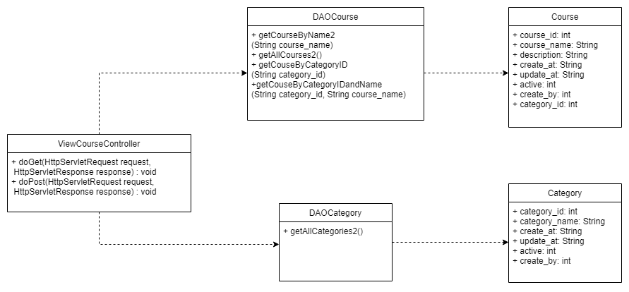

### 5.2 Sequence Diagram(s)

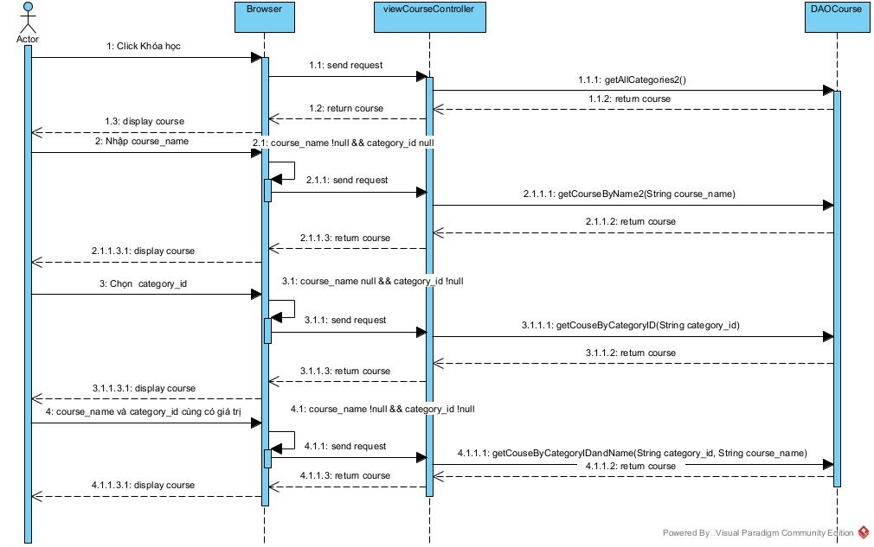

### 5.3 Database Queries

### 5.3.1 getAllCourses2

select * from [course]

### 5.3.2 getCourseByName2(String course_name)

select course_name,description from [course] where course_name like ?

### 5.3.3 getCouseByCategoryID(String category_id)

select course_name,course_id,description

from Category ca INNER Join Course c

on ca.category_id = c.category_id

where c.category_id = ?

### 5.3.3 getCouseByCategoryIDandName(String category_id, String course_name)

select course_name,course_id,description

from Category ca INNER Join Course c

on ca.category_id = c.category_id

where c.category_id = ? and c.course_name like ?

## 6. View Top Ranking

### 6.1 Class Diagram

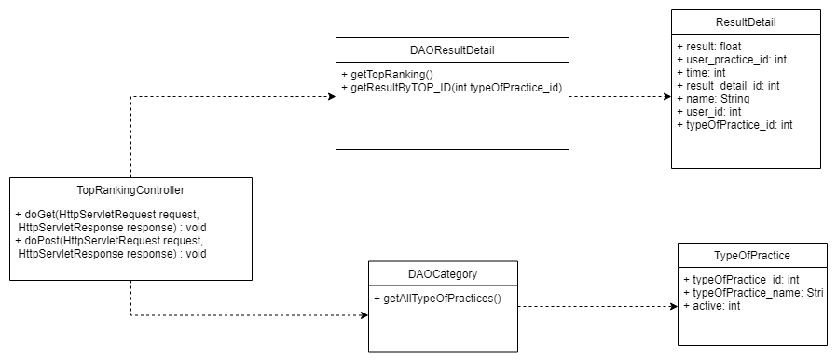

### 6.2 Sequence Diagram(s)

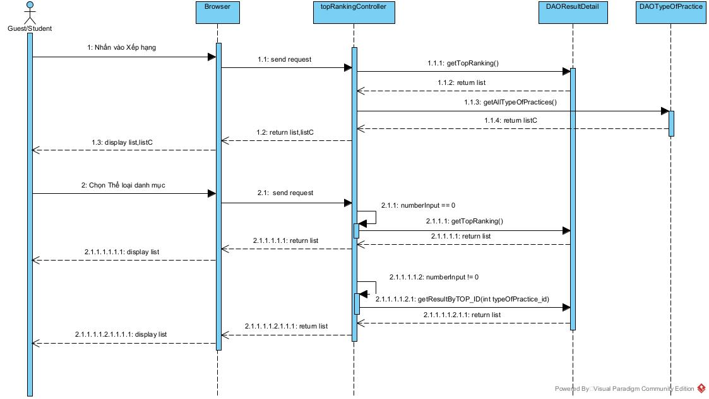

### 6.3 Database Queries

### 6.3.1 getTopRanking()

SELECT u.name, u.user_id,SUM(rd.result) AS total_result,SUM(rd.time) AS total_time

FROM [User] u

INNER JOIN User_Practice up ON u.user_id = up.user_id

INNER JOIN Type_Of_Practice tp ON up.TOP_id = tp.TOP_id

INNER JOIN Result_Detail rd ON rd.user_practice_id = up.user_practice_id

WHERE tp.TOP_id IN (1, 2, 3)\n"

GROUP BY u.name, u.user_id\n"

ORDER BY total_result DESC;

### 6.3.2 getAllTypeOfPractices()

select * from [Type_Of_Practice]

### 6.3.3 getResultByTOP_ID(int typeOfPractice_id)

SELECT name,u.user_id, tp.TOP_name, SUM(rd.result) AS total_result, SUM(rd.time) AS total_time

from [User] u

INNER JOIN User_Practice up ON u.user_id = up.user_id

INNER JOIN Type_Of_Practice tp on up.TOP_id = tp.TOP_id

INNER JOIN Result_Detail rd on rd.user_practice_id = up.user_practice_id

where tp.TOP_id=?

GROUP BY u.name, u.user_id, tp.TOP_name

ORDER BY total_result DESC;

### 7. View all courses enrolled

### 7.1 Class Diagram

### 7.2 Sequence Diagram(s)

### 7.3 Database Queries

SELECT c.course_id FROM User_Enroll_Course uec

JOIN Course c ON uec.course_id = c.course_id

WHERE uec.user_id = ? AND status=1

## 8. Search and Filter course enrolled

### 8.1 Class Diagram

### 8.2 Sequence Diagram(s)

### 8.3 Database Queries

8.3.1

SELECT c.* FROM User_Enroll_Course uec

JOIN Course c ON uec.course_id = c.course_id

WHERE uec.user_id = ? AND c.course_name LIKE ? AND status=1

8.3.2

SELECT c.* FROM Course c

INNER JOIN User_Enroll_Course uec ON c.course_id = uec.course_id

INNER JOIN Category cat ON c.category_id = cat.category_id

WHERE uec.user_id = ? AND status=1 AND cat.category_name IN()

## 9. Course detail

### 9.1 Class Diagram

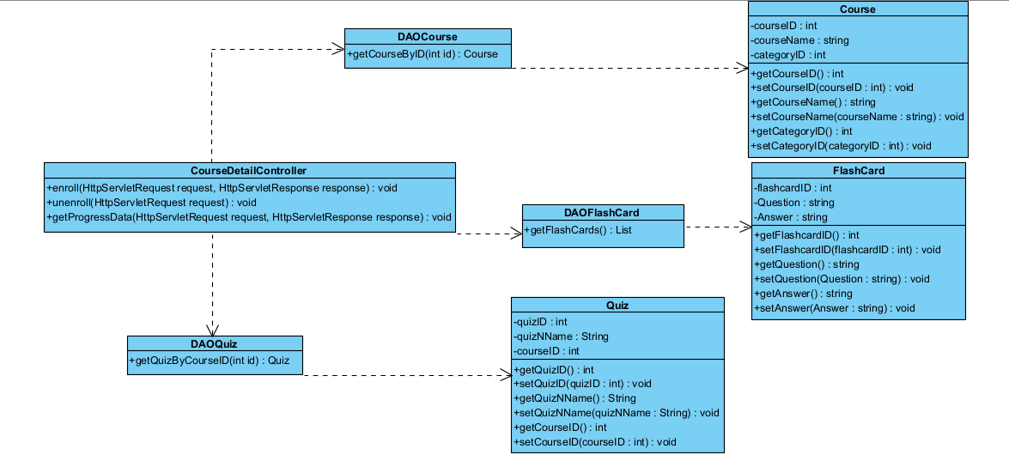

### 9.2 Sequence Diagram(s)

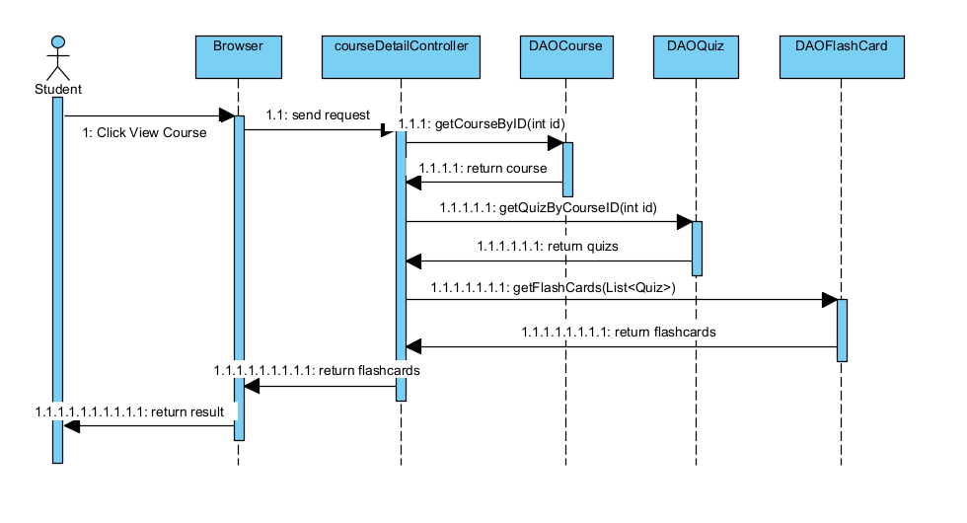

### 9.3 Database Queries

select * from [course] where course_id = ?

select * from quiz where course_id = ?

select * from flashcard where flashcard_id = ?

## 10. Practice Multiple Choice

### 10.1 Class Diagram

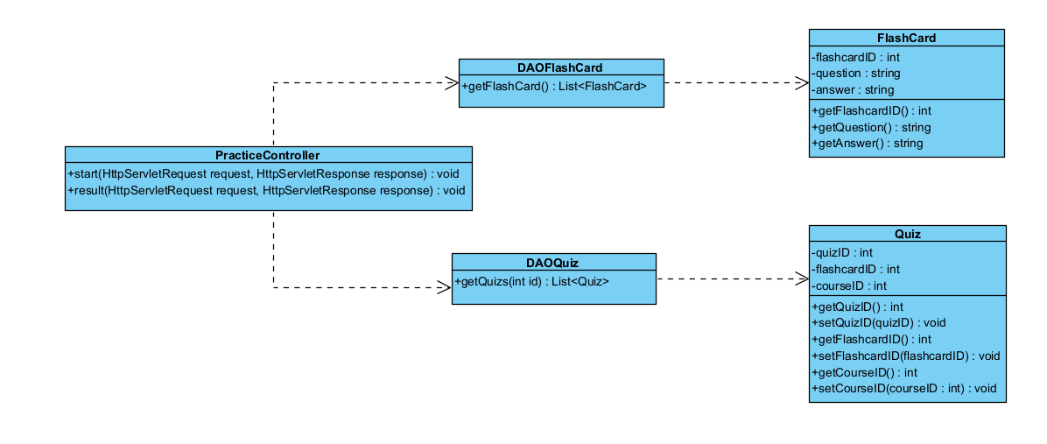

### 10.2 Sequence Diagram(s)

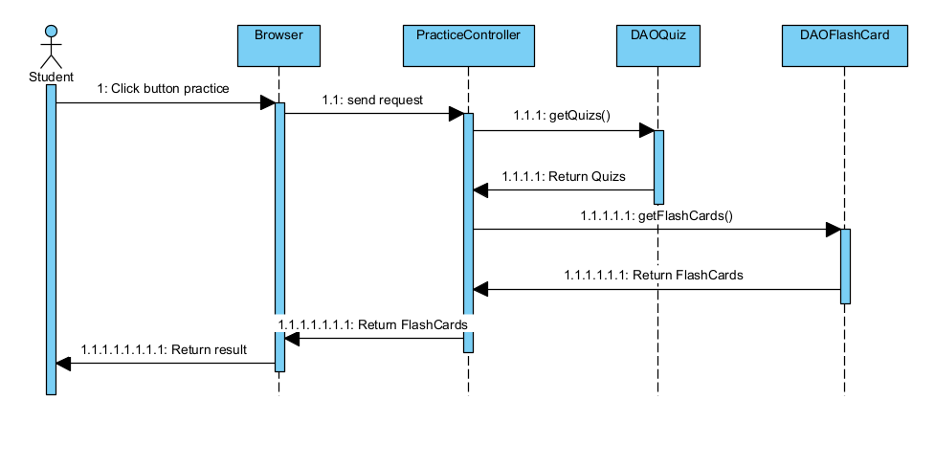

### 10.3 Database Queries

select * from quiz where course_id = ?

select * from flashcard where flashcard_id = ?

## 11. ManageCourse

### 11.1 Class Diagram

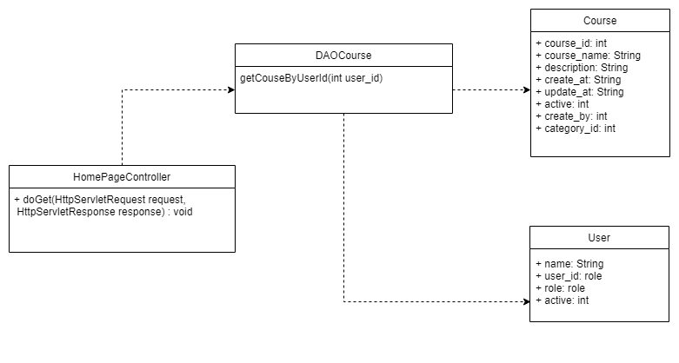

### 11.2 Sequence Diagram(s)

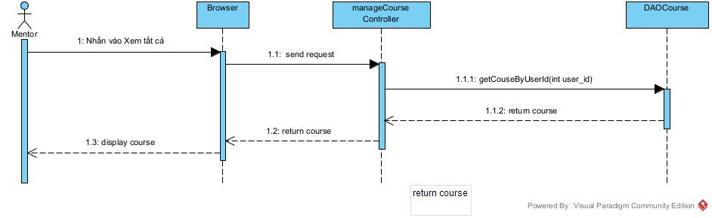

### 11.3 Database Queries

### 11.3.1 getCouseByUserId(int user_id)

select c.course_id,c.course_name,ca.category_name,ca.category_id,

c.description,c.create_at,c.update_at,c.active

from Course c inner join [User] u

on c.created_by = u.user_id

inner join Category ca on c.category_id = ca.category_id

where u.user_id = ?